Supplementary Information
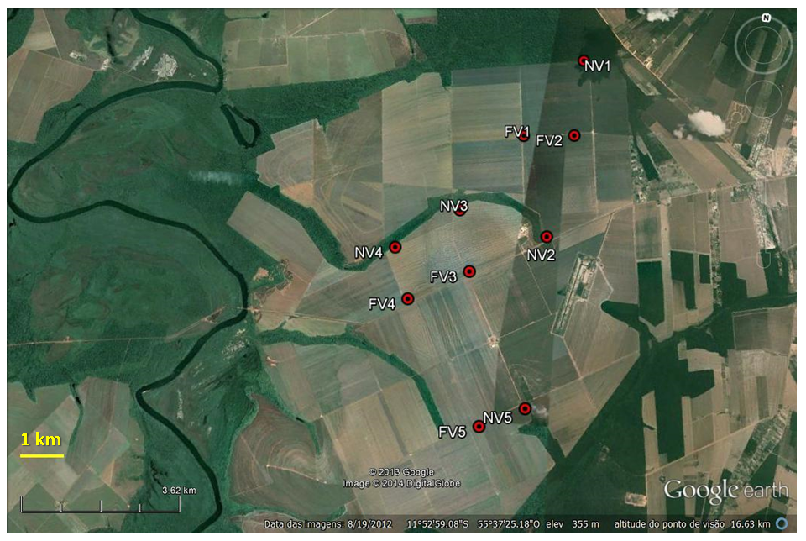
Figure S1: Study sites on the conventional cotton farm (4’393 ​​hectares) in Sinop, Mato Grosso state, Brazil (11°52'89"S, 55°36'01"W) showing the five plots (NV 1 to NV 5) near natural vegetation and the other five (FV 1 to FV 5) far from natural vegetation. Source: Google Earth (2013)

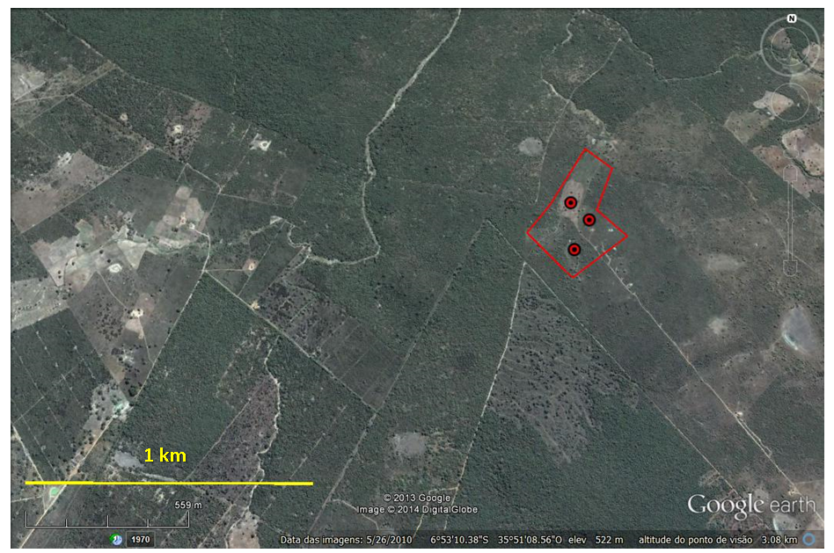
Figure S2: Study site on the organic farm (8 hectares) in Remígio, Paraíba state, Brazil (6°53'83'S, 35°49'07"W). Source: Google Earth

Table S1: Fibre weight and parameters of quality (short fibre content, fibre resistance and maturity) measured in plots near to and far from natural vegetation in the 2010/2011 season on a conventional farm in Sinop – Mato Grosso state, Brazil.
Parameters | Near natural vegetation (NV) | Far from natural vegetation (FV) | Statistic Test¹
Fibre weight (gr) | 29.8 ± 9.84 | 30.68 ± 9.76 | W = 1277.0; p=0.85
Short fibre content - SFC (w) % < 12.7 | 6.75± 1.07 | 12.9 ± 21.99 | W = 1062.5; p=0.19
Fibre resistance - micronaire (µg / pol²) | 3.93 ± 0.68 | 4.19 ± 1.2 | W = 1183.5; p=0.65
Fibre Maturity | 85.56 ± 1.83 | 91.7 ± 22.6 | W = 1153.5; p=0.5
¹ Wilcoxon test (W)

Table S2: Fibre fraction and parameters of quality (short fibre content, fibre fineness and maturity)measured in cotton bolls from spontaneous self-pollination (SS) and open pollination (OP) on an organic cotton farm.
Parameters | Mean (SS) | Mean (OP) | Statistic Test¹ | N² (SS) | N² (OP)
Fibre fraction (%) | 39.39± 2.88 | 40.14± 6.29 | t = -0.88; p = 0.38 | 64 | 74
Short fibre content - SFC (w) %<12,7 | 4.70 ±1.46 | 5.22 ±1.74 | t= -1.87; p = 0.06 | 63 | 74
Mean fibre fineness -  Fine m Tex millitex (milligramas/1000 metros) | 161.62 ±10.99 | 162.94 ±12.15 | t= -0.66; p = 0.51 | 63 | 74
Fibre maturity –MatRatio (mature fibre in relation to immature fibre) | 0.90 ±0.03 | 0.91 ±0.04 | t= -0.03; p = 0.97 | 63 | 74
Immature fibre content – IFC (%) | 4.89 ±0.98 | 5.04 ±1.09 | t= -0.81; p = 0.42 | 63 | 74
¹ Student’s t test (t); ² N= number of repetitions.

Table S3: Characteristics of commercial cotton varieties cultivated in the experimental areas.
¹ FM 910 = variety from Bayer, Fibermax 910, Barbosa et al 2010;
Characteristics | FM 910¹ | BRS 187 8H²
Yield (Standard sample) | 4’000 kg/ha | 2’599 kg/ha
Fibre weight | 1’700 kg/ha | 1’006 kg/ha
Fibre percentage | 42.6% | 38.70%
Fibre resistance - micronaire (µg / pol²) | 3.8 a 4.4 | 4.5
Boll weight | 5.10g | 6.30g
Fibre length (mm³) | 28 to 32 mm³ | 28.1mm³
² BRS 187 8H = variety from Embrapa, BRS 8H, Ribeiro et al 2000

References
Barbosa CAS, Reis K, Miranda LMBS, Silva RA, Silva RA, Chaves JO, Olegário AM, Brugnera P, Breda CE (2010) Avaliação de diferentes variedades de Algodão cultivada no sistema de Plantio Tradicional no oeste da Bahia. Circulo Verde Assessoria Agronômica e Pesquisa.[on line] URL: http://circuloverde.com.br/art/safra_0910/algodao/ensaio_variedades_algodao.pdf (accessed March 2013).
Google Earth (2013) US Dept. of State Geographer Data SIO, NOAA, U.S. NAVY, NGA, GEBCO ©
Ribeiro JL, Freire EC, Farias FJC, Andrade FP, Costa JN, Medeiros JC, Santana JCF (2002) Cultivares de algodoeiro herbáceo recomendadas para os Cerrados do Meio-Norte do Brasil.[online] URL:http://www.cnpa.embrapa.br/produtos/algodao/publicacoes/trabalhos_cba4/230.pdf (accessed March 2013)

