Supplementary material to Insect pollination improves yield of Shea (Vitellaria paradoxa subsp. paradoxa) in the agroforestry parklands of West Africa by Stout et al.
Appendix I: Mean fruit set per inflorescence (±SE) at each site for a) open vs. bagged inflorescences and b) hand pollinated vs. open inflorescences.
a)
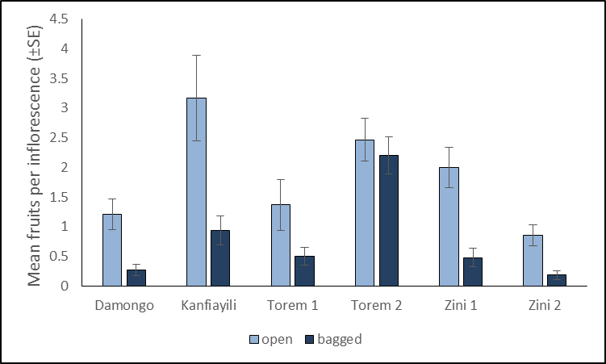
b)
