Supplementary information
Toivonen, M., Herzon, I., Toikkanen, J., Kuussaari, M. 2021. Linking pollinator occurrence in field margins to pollinator visitation to a mass-flowering crop. Journal of Pollination Ecology.

Appendix I. Species list

Table A.1. Numbers of pollinator individuals, and the percentage of each species or species group of all pollinators recorded in field margins and on turnip rape flowers in adjacent fields. Only bees, butterflies and syrphid flies were counted in field margins, whereas in the crop, all crop-visiting insects were recorded.

 | Field margins |  | Turnip rape
 | Number of individuals | % | Number of individuals | %
All pollinators | 948 | 100.0 | 743 | 100.0
Honeybees (Hymenoptera: Apis mellifera) | 146 | 15.4 | 381 | 51.3
Bumblebees (Hymenoptera: Bombus) | 146 | 15.4 | 73 | 9.8
Bombus lucorum -group | 70 | 7.4 | 53 | 7.1
Bombus lapidarius | 12 | 1.3 | 7 | 0.9
Bombus pratorum | 8 | 0.8 | 5 | 0.7
Bombus pascuorum | 15 | 1.6 | 4 | 0.5
Psithyrus-group | 16 | 1.7 | 0 | 0.0
Bombus hortorum | 2 | 0.2 | 2 | 0.3
Bombus soroensis | 2 | 0.2 | 1 | 0.1
Bombus ruderarius | 6 | 0.6 | 1 | 0.1
Bombus hypnorum | 7 | 0.7 | 0 | 0.0
Bombus veteranus | 6 | 0.6 | 0 | 0.0
Bombus distinguendus | 1 | 0.1 | 0 | 0.0
Bombus rupestris | 1 | 0.1 | 0 | 0.0
Solitary bees (Hymenoptera: Anthophila) | 37 | 3.9 | 26 | 3.5
Butterflies (Lepidoptera: Papilionoidea) | 280 | 29.5 | 5 | 0.7
Aphantopus hyperantus | 135 | 14.2 | 0 | 0.0
Pieris napi | 60 | 6.3 | 0 | 0.0
Brenthis ino | 18 | 1.9 | 2 | 0.3
Nymphalis urticae | 17 | 1.8 | 2 | 0.3
Polyommatus amandus | 10 | 1.1 | 0 | 0.0
Thymelicus lineola | 9 | 0.9 | 0 | 0.0
Ochlodes sylvanus | 6 | 0.6 | 1 | 0.1
Coenonympha glycerion | 4 | 0.4 | 0 | 0.0
Argynnis aglaja | 3 | 0.3 | 0 | 0.0
Vanessa atalanta | 3 | 0.3 | 0 | 0.0
Nymphalis io | 2 | 0.2 | 0 | 0.0
Araschnia levana | 2 | 0.2 | 0 | 0.0
Polyommatus semiargus | 2 | 0.2 | 0 | 0.0
Aricia artaxerxes | 1 | 0.1 | 0 | 0.0
Argynnis niobe | 1 | 0.1 | 0 | 0.0
Boloria euphrosyne | 1 | 0.1 | 0 | 0.0
Limenitis populi | 1 | 0.1 | 0 | 0.0
Pieris brassicae | 1 | 0.1 | 0 | 0.0
Pieris rapae | 1 | 0.1 | 0 | 0.0
Polyommatus icarus | 1 | 0.1 | 0 | 0.0
Pontia daplidice | 1 | 0.1 | 0 | 0.0
Vanessa cardui | 1 | 0.1 | 0 | 0.0
Syrphid flies (Diptera: Syrphidae) | 339 | 35.8 | 131 | 17.6
Eristalinae | - | - | 47 | 6.3
Syrphinae | - | - | 84 | 11.3
Other pollinators | - | - | 127 | 17.1
Other flies (Diptera) | - | - | 117 | 15.7
other Brachycera | - | - | 110 | 14.8
Nematocera | - | - | 7 | 0.9
Sawflies (Hymenoptera: Symphyta) | - | - | 4 | 0.5
Rose chafer (Coleoptera: Cetonia aurata) | - | - | 2 | 0.3
True bugs (Hemiptera: Heteroptera) | - | - | 2 | 0.3
Dragonflies (Odonata) | - | - | 1 | 0.1
Lacewings (Neuroptera: Chrysopidae) | - | - | 1 | 0.1

Appendix II. Supplementary analyses

Interactive effects of habitat type (field vs. margin) and landscape heterogeneity (distance to forest, forest cover within the 500-m buffer, or forest cover within the 1-km buffer) on pollinator species richness and abundance, when fields with exceptionally high pollinator abundance were excluded from the analysis

When one field with exceptionally high number of honeybees was excluded from the analysis, the interaction of habitat type with all three landscape heterogeneity measures had statistically significant effect on total pollinator abundance (Tab. A.2, Fig. A.1). For honeybee and bumblebee abundance, the interactions of habitat type and landscape heterogeneity remained statistically nonsignificant, when fields with exceptional honeybee or bumblebee abundance were excluded from the analysis.

Table A.2. Generalised linear mixed model results of the interactive effects of habitat type (field vs. margin) and landscape heterogeneity (distance to forest, forest cover within a 500 m buffer, or forest cover within a 1 km buffer) on the abundances of all pollinators, honeybees and bumblebees, when fields with exceptionally high pollinator abundance were excluded from the analysis. For total pollinator abundance and honeybee abundance, one field with exceptionally high number of honeybees was excluded. For bumblebees, one field with exceptional bumblebee abundance was excluded.

 | Distance to forest (km) |  |  |  | Forest (%) in 500-m buffer |  |  |  | Forest (%) in 1-km buffer
 | Estimate | SE | Z | P | Estimate | SE | Z | P | Estimate | SE | Z | P | Model type
Total abundance
(Intercept) | 2.951 | 0.232 | 12.735 | < 0.001 | 2.004 | 0.266 | 7.519 | < 0.001 | 1.676 | 0.311 | 5.382 | < 0.001 | neg. bin.
Margin | 0.179 | 0.163 | 1.099 | ns | 0.880 | 0.211 | 4.175 | < 0.001 | 1.181 | 0.286 | 4.132 | < 0.001
Landscape heterogeneity | -4.121 | 1.106 | -3.726 | < 0.001 | 0.013 | 0.004 | 3.673 | < 0.001 | 0.017 | 0.004 | 4.081 | < 0.001
Flower coverage in margin | 0.015 | 0.008 | 1.834 | ns | 0.020 | 0.009 | 2.370 | < 0.05 | 0.020 | 0.008 | 2.366 | < 0.05
Margin * Landscape heterogeneity | 3.011 | 1.324 | 2.274 | < 0.05 | -0.012 | 0.005 | -2.654 | < 0.01 | -0.015 | 0.005 | -2.966 | < 0.01
Honeybees
(Intercept) | 2.069 | 0.424 | 4.883 | < 0.001 | 1.643 | 0.473 | 3.478 | < 0.001 | 1.544 | 0.556 | 2.776 | < 0.01 | neg. bin.
Margin | -1.010 | 0.353 | -2.863 | < 0.01 | -0.184 | 0.360 | -0.512 | ns | 0.178 | 0.507 | 0.352 | ns
Landscape heterogeneity | -0.997 | 1.444 | -0.691 | ns | 0.008 | 0.006 | 1.342 | ns | 0.008 | 0.007 | 1.152 | ns
Flower coverage in margin | 0.009 | 0.016 | 0.557 | ns | 0.009 | 0.017 | 0.544 | ns | 0.010 | 0.017 | 0.560 | ns
Margin * Landscape heterogeneity | 2.470 | 2.192 | 1.127 | ns | -0.019 | 0.010 | -1.872 | ns | -0.021 | 0.012 | -1.842 | ns
Bumblebees
(Intercept) | -0.164 | 0.489 | -0.336 | ns | -0.400 | 0.532 | -0.752 | ns | -0.836 | 0.668 | -1.251 | ns | neg. bin.
Margin | 0.762 | 0.374 | 2.035 | < 0.05 | 1.240 | 0.432 | 2.870 | < 0.01 | 1.735 | 0.622 | 2.790 | < 0.01
Landscape heterogeneity | -3.239 | 2.503 | -1.294 | ns | -0.001 | 0.009 | -0.086 | ns | 0.008 | 0.010 | 0.848 | ns
Flower coverage in margin | 0.033 | 0.016 | 2.102 | < 0.05 | 0.031 | 0.015 | 2.005 | < 0.05 | 0.032 | 0.015 | 2.048 | < 0.05
Margin * Landscape heterogeneity | 4.229 | 2.793 | 1.514 | ns | -0.002 | 0.011 | -0.188 | ns | -0.012 | 0.012 | -1.040 | ns

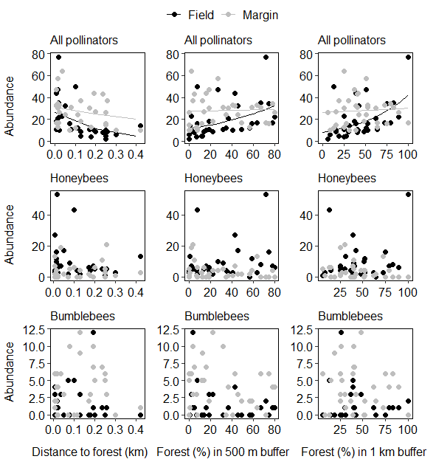

Fig. A.1. Abundances of all pollinators, honeybees and bumblebees in turnip rape fields and permanent margins in relation to three measures of landscape heterogeneity (distance to forest, forest cover within the 500-m buffer, and forest cover within the 1-km buffer), when fields with exceptionally high pollinator abundance were excluded. For total pollinator abundance and honeybee abundance, one field with exceptionally high number of honeybees was excluded. For bumblebees, one field with exceptional bumblebee abundance was excluded. Lines in the scatterplots depict predicted values based on generalised linear mixed models with statistically significant interaction effect of habitat type and landscape heterogeneity (Tab. A.2).

Pollinator abundance in field margins as a predictor of the abundance of crop visitors, when fields with exceptionally high pollinator abundance were excluded from the analysis

When the fields with exceptionally high honeybee or bumblebee abundance were excluded from the analyses, the statistical significance of the relationship between abundance in field margins and in the crop was lost for honeybees and bumblebees (Tab. A.3).

Table A.3. Occurrence frequency and mean abundance of all pollinators, honeybees and bumblebees in turnip rape fields and field margins, and the results of generalised linear models explaining pollinator abundance in turnip rape fields with their abundance in adjacent field margins, when fields with exceptionally high pollinator abundance were excluded from the analysis. For total pollinator abundance and honeybee abundance, one field with exceptionally high number of honeybees was excluded. For bumblebees, one field with exceptional bumblebee abundance was excluded.

 | Summary statistics |  |  |  | GLM results
 | Fields |  | Margins
 | Freq.-% | Mean | Freq.-% | Mean | Estimate | SE | Z | P | Model type
Pollinator abundance (n = 33) | 100 | 19.0 | 100 | 27.3 | 0.003 | 0.010 | 0.309 | ns | neg. bin.
Honeybees (n = 33) | 94 | 8.9 | 70 | 3.8 | -0.006 | 0.034 | -0.176 | ns | neg. bin.
Bumblebees (n = 33) | 48 | 1.4 | 79 | 3.9 | 0.090 | 0.085 | 1.062 | ns | neg. bin.

