Appendices to J Poll Ecol 35(18), Carvalheiro et al.
DOI: 10.26786/1920-7603(2023)756
Appendix 1. Statistical details for analysis of the chemical composition of leaves (N and C content) and pollen (relative abundance, RA, and total abundance, TA, of each of the 17 amino acids). Each analysis was repeated with (Nadd: ‘yes’ vs ‘no’) and without (Treatment: control, N and NP) treatments N and NP lumped together. All models were run using parcel as a random effect, and p-values were extracted with log-likelihood ratio tests.
(Separate csv file with a spreadsheet)

Appendix 2. Effect of pollen weight on the variability of amino acid relative content in samples not exposed to fertilization experiments (General linear mixed models, Gamma distribution, log link function, AA within plot as random structure). N – total number of samples for each of the 17 amino acids analysed; χ² and p-values of likelihood ratio tests on the effect of ‘weight’ are provided.
Threshold (mg) | N | Effect size | χ² | P-value
0 | 18 | -0.35333 | 28.6 | <0.0001
0.25 | 17 | -0.37590 | 31.3 | <0.0001
0.5 | 13 | -0.15519 | 3.3 | 0.0681
0.75 | 11 | -0.20226 | 4.9 | 0.0267
1 | 8 | -0.06357 | 0.2 | 0.6319
1.25 | 5 | 0.04088 | 0.04 | 0.8366

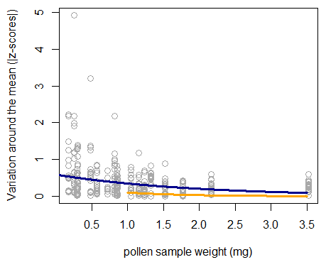
Appendix 3. Effect of pollen weight on the variability (z-scores) of results obtained for pollen amino acids relative content around the mean when using all samples (blue line), and when using only samples with more than 1mg of pollen (orange line). The field study in Cerrado led to 31 samples with pollen weights ranging from 0.18 mg to 3.52 mg of pure pollen per sample. Among these samples, 18 were from control plots, 10 were from plots that received N addition, and three were from plots that received NP addition. Stabilization of values of amino acid content (i.e., lack of effect of pollen weight) only occurs for samples with more than 1mg of pollen (orange line). Lines represent the fitted values obtained with GLMM (Gamma distribution). For statistical details see Appendix 2.

