
Appendices to J Poll Ecol 38(4), Jaeger et al.
DOI: 10.26786/1920-7603(2025)824

Appendix 1. Abronia ameliae volatile organic compounds data, floral visitors, herbivores, hand-crossed hybrids, and pollination model details.

Table S1. List of compounds detected in Abronia ameliae samples, ordered by retention times. Minor compounds detected in only a single sample or with emission values of <5.0 ng/g/hr are not shown. Abundance refers to the mean value across samples and is expressed in units of ng/g/hour. MSE refers to mean standard error. For compound IDs, compounds shown in bold were confirmed with authentic standards. For compounds without authentic standards but with mass spectral library scores of 90 or higher, or with diagnostic mass ions, we report tentative compound identities, as well as the predominant mass ions. For mass ions, the presumed parent ion is reported first, the base peak is shown in bold, and all ions with intensity scores of >50 are reported in italics. Quality scores are based on matches to the NIST mass spectral library. Sample refers to sample IDs containing representative examples of each compound. Class refers to the broad biosynthetic class of each compound.
Retention Time | Abundance | MSE | Compound ID | Quality Score | Sample | Class
8.694 | 65.3 | 18.4 | alpha-pinene | 95 | M101 | monoterpene
9.547 | 1520.8 | 766.3 | benzaldehyde | 94 | M127 | benzenoid / phenylpropanoid
10.485 | 11.7 | 4.1 | 6-methyl-5-hepten-2-one  (m/z – 126, 111, 108, 69, 67, 55) | 90 | M127 | irregular terpene
11.493 | 177.3 | 82.8 | p-methylanisole | 97 | M127 | benzenoid / phenylpropanoid
11.779 | 10.2 | 5.9 | limonene  (m/z – 136, 121, 107, 93, 79, 77, 68, 67) | 97 | M110 | monoterpene
11.944 | 374.7 | 148.2 | benzyl alcohol | 97 | M127 | benzenoid / phenylpropanoid
12.156 | 12.5 | 5.9 | vinyl-valerolactone  (m/z – 126, 111, 99, 71, 67, 55) | 90 | M127 | miscellaneous cyclic compounds
12.534 | 428.0 | 174.6 | unknown compound  (m/z – 139, 111, 93, 91, 81, 77, 69, 67, 55) | 72 | M125 | undetermined
13.146 | 42.4 | 19.7 | unknown compound  (m/z – 126, 111, 93, 81, 69, 55) | 50 | M125 | undetermined
13.323 | 142.0 | 82.0 | p-cresol  (m/z – 108, 107, 79, 77, 51) | 96 | M127 | benzenoid / phenylpropanoid
14.211 | 75.7 | 19.1 | nonanal  (m/z – 142, 114, 98, 82, 70, 57, 56, 55) | 90 | M127 | aliphatic
15.401 | 54.6 | 24.1 | lilac aldehyde, unknown stereoisomer 2  (m/z – 153, 111, 93, 81, 71, 67, 55) | 72 | M110 | monoterpene
15.624 | 114.7 | 32.2 | lilac aldehyde, unknown stereoisomer 1  (m/z – 153, 111, 93, 81, 71, 67, 55) | 80 | M125 | monoterpene
16.030 | 634.0 | 359.0 | benzyl acetate | 98 | M127 | benzenoid / phenylpropanoid
16.200 | 48.0 | 25.0 | lilac aldehyde, unknown stereoisomer 3  (m/z – 155, 111, 93, 81, 71, 55, 43) | 76 | S141 | monoterpene
16.247 | 14.5 | 6.8 | levomenthol  (m/z – 156, 138, 123, 109, 95, 81, 71, 69, 55) | 91 | M127 | monoterpene
17.100 | 199.1 | 62.1 | lilac alcohol, unknown stereoisomer 2  (m/z – 170, 155, 111, 93, 71, 67, 55) | 89 | M127 | monoterpene
17.409 | 295.3 | 87.3 | lilac alcohol, unknown stereoisomer 1  (m/z – 170, 155, 111, 93, 81, 71, 67, 55) | 95 | M110 | monoterpene
16.911 | 7.1 | 6.6 | methyl salicylate | 96 | M101 | benzenoid / phenylpropanoid
17.266 | 16.8 | 5.1 | decanal  (m/z – 156, 112, 95, 83, 82, 81, 70, 69, 68, 67, 57, 55) | 90 | M110 | aliphatic
17.855 | 49.5 | 14.6 | lilac alcohol, unknown stereoisomer 3  (m/z – 170, 155, 111, 93, 81, 67, 55) | 90 | M101 | monoterpene
18.233 | 87.1 | 32.4 | 3,4-dimethoxytoluene  (m/z – 152, 137, 109, 91, 77) | 98 | M127 | benzenoid / phenylpropanoid
18.611 | 5.3 | 3.8 | chavicol  (m/z – 134, 133, 107, 105, 84, 79, 77) | 93 | M125 | benzenoid / phenylpropanoid
22.456 | 26.3 | 24.1 | benzyl isovalerate  (m/z – 192, 108, 91, 85, 57) | 94 | M127 | benzenoid / phenylpropanoid
22.633 | 173.3 | 58.2 | cis-jasmone  (m/z – 164, 149, 135, 131, 122, 110, 93, 91, 79, 77, 67, 55, 53) | 97 | M125 | miscellaneous cyclic compounds
22.736 | 414.7 | 102.3 | methyleugenol  (m/z – 178, 163, 147, 107, 103, 91) | 98 | M125 | benzenoid / phenylpropanoid
23.183 | 61.5 | 26.3 | carryophyllene | 99 | M127 | sesquiterpene
22.393 | 13.0 | 11.9 | beta-cubebene  (m/z – 204, 161, 133, 119, 105, 91, 79) | 96 | M110 | sesquiterpene
23.972 | 39.7 | 7.3 | geranyl acetone  (m/z – 194, 151, 136, 107, 69, 67) | 93 | M127 | irregular terpene
24.064 | 13.0 | 4.9 | humulene  (m/z – 204, 161, 147, 121, 107, 93, 91, 80, 79) | 93 | M127 | sesquiterpene
24.739 | 76.1 | 33.7 | germacrene  (m/z – 204, 161, 133, 119, 105, 91, 81) | 98 | M110 | sesquiterpene
24.750 | 9.9 | 5.0 | unknown sesquiterpene  (m/z – 204, 161, 134, 119, 105, 91, 81, 79, 77) | 95 | M127 | sesquiterpene
25.054 | 7.7 | 2.7 | methylisoeugenol (unknown isomer)  (m/z – 178, 163, 135, 107, 103, 91, 77) | 98 | M127 | benzenoid / phenylpropanoid
25.197 | 8.9 | 4.7 | unknown sesquiterpene  (m/z – 204, 161, 147, 119, 105, 93, 81, 73, 58) | 92 | M110 | sesquiterpene
25.551 | 5.2 | 2.2 | unknown sesquiterpene  (m/z – 207, 204, 161, 119, 105, 91) | 83 | M127 | sesquiterpene
25.763 | 20.3 | 6.3 | beta-cadinene  (m/z – 204, 189, 161, 134, 119, 105, 91, 81, 77) | 95 | M110 | sesquiterpene
26.347 | 14.7 | 6.9 | unknown sesquiterpene  (m/z – 219, 189, 161, 135, 121, 107, 93, 81, 79, 69, 67, 59, 55) | 80 | M125 | sesquiterpene
28.636 | 11.8 | 6.0 | methyl jasmonate  (m/z – 224, 151, 133, 107, 95, 91, 83, 77, 55) | 97 | M101 | miscellaneous cyclic compounds
28.739 | 25.3 | 8.1 | beta-eudesmol  (m/z/ - 222, 189, 164, 149, 135, 121, 109, 95, 91, 81, 79, 67, 59) | 96 | M101 | sesquiterpene
31.216 | 9.0 | 5.8 | benzyl benzoate | 93 | M101 | benzenoid / phenylpropanoid

Table S2. Fixed effect coefficients from the summary outputs for the selected pollination models in the Texas natural population and the Michigan common garden. Significance codes: 0 ‘***’, 0.001 ‘**’, 0.01 ‘*’, 0.05 ‘.’, 0.1 ‘ ’, 1.
Texas natural population
 | Estimate | Std. Error | z value | Pr(>|z|)
Intercept | 1.21602 | 0.23408 | 5.195 | 2.05e-07 ***
Treatment (Night) | -0.32084 | 0.11860 | -2.705 | 0.00683 **
Treatment (Open) | -0.01202 | 0.12393 | -0.097 | 0.92273
Flowering Period | 0.07466 | 0.03495 | 2.137 | 0.03264 *
Michigan common garden
 | Estimate | Std. Error | z value | Pr(>|z|)
Intercept | -0.71137 | 0.21881 | -3.251 | 0.00115 **
Treatment (Night) | -0.74040 | 0.07688 | -9.631 | < 2e-16 ***
Treatment (Open) | 0.09605 | 0.06735 | 1.426 | 0.15383

Figure S1. Representative chromatogram from A. ameliae sample M127, with annotations added for primary compounds; names in bold correspond to compounds whose IDs were confirmed with authentic standards.

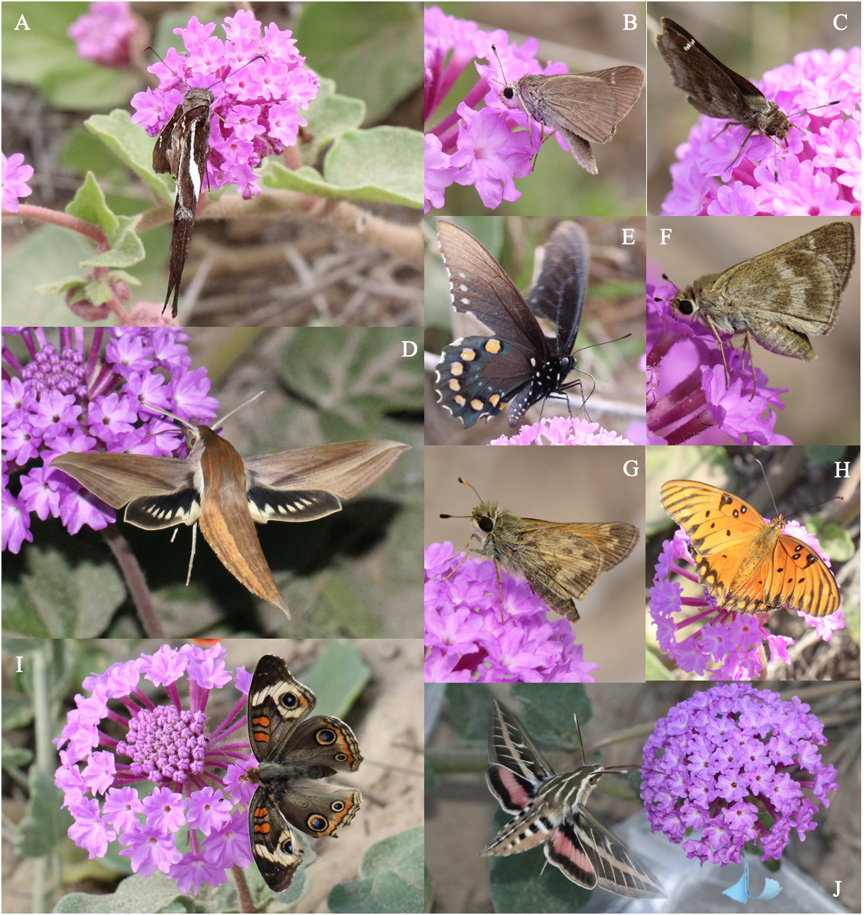
Figure S2. Abronia ameliae floral visitors in the Texas field experiment: A) Chioides catillus, B) Lerodea eufala, C) Lerema accius, D) Xylophanes tersa, E) Battus philenor, F) Polites vibex, G) Atalopedes campestris, H) Agraulis vanilla, I) Junonia coenia, and J) Hyles lineata. Photos credit: Eric LoPresti.

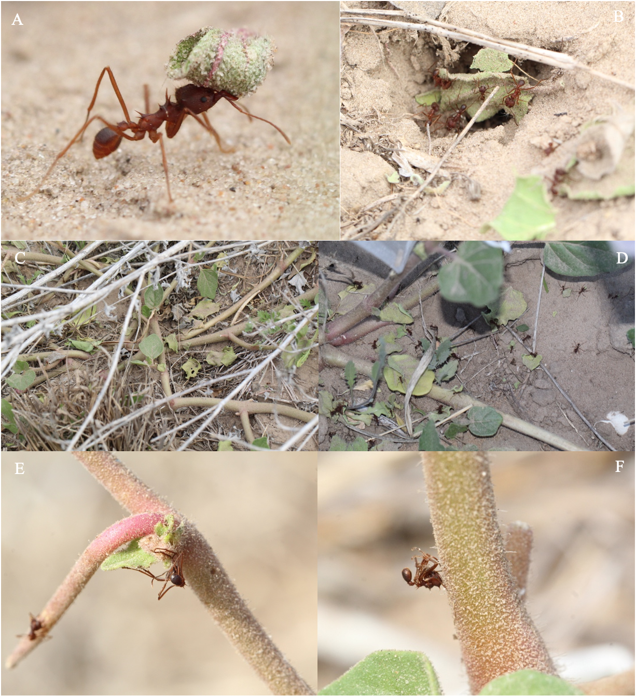
Figure S3. Abronia ameliae herbivory and possible herbivore defense. A-B) Atta texana (leafcutter ants) carrying A. ameliae leaves to their nest. C-D) Destructive damage of most leaves of several A. ameliae plants. E-F) Ants stuck to A. ameliae’s glandular trichomes. Photos credit: Eric LoPresti.

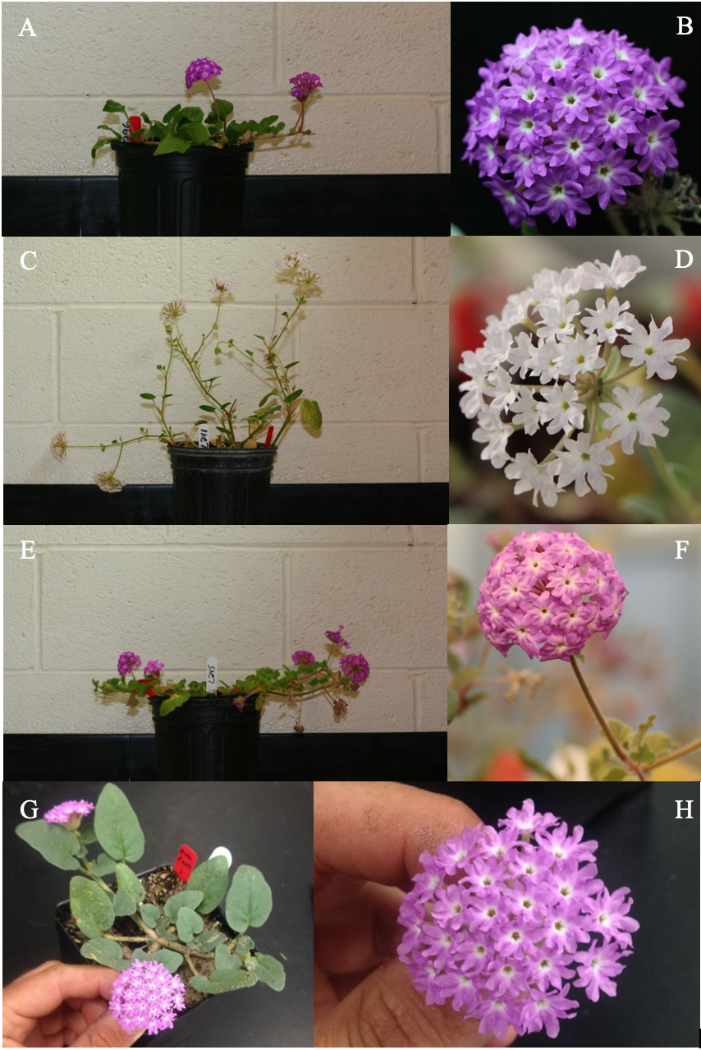
Figure S4. Hand-crossed and lab-grown A. ameliae hybrids: A-B) ♀A. umbellata x ♂A. ameliae, C-D) ♀A. ameliae x ♂A. turbinata, E-F) ♀A. villosa x ♂A. ameliae, and G-H) ♀A. pogonantha x ♂A. ameliae. Photos credit: Eric LoPresti.

