
Appendices to J Poll Ecol 38(12), Visser et al.
DOI: 10.26786/1920-7603(2025)834

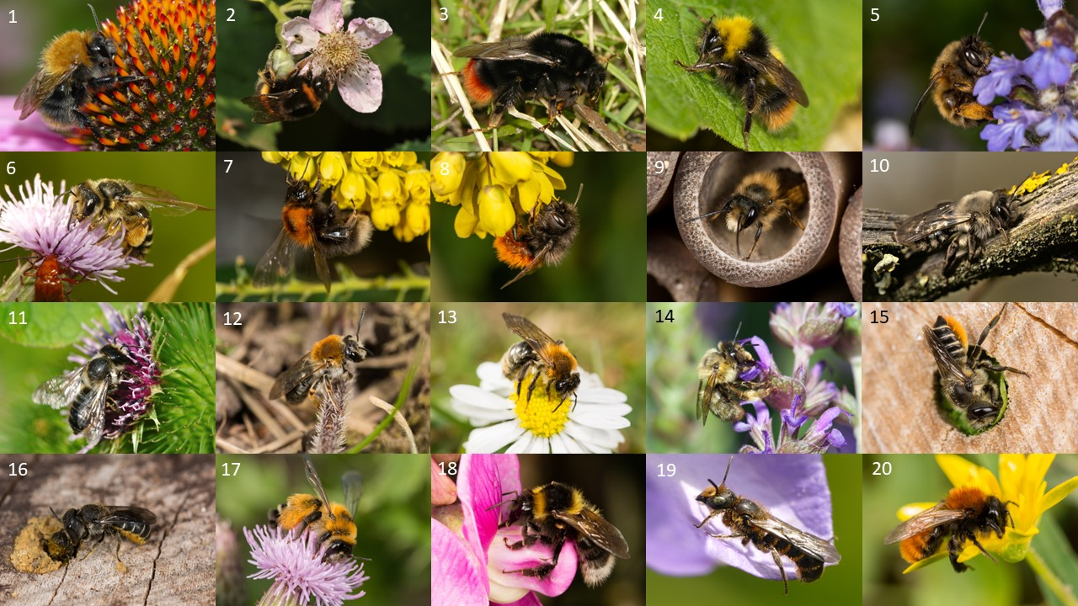
Figure S1: top 20 bees for the AS-dataset: 1. Bombus pascuorum (Apidae), 2. Bombus terrestris (Apidae), 3. Bombus lapidarius (Apidae), 4. Bombus pratorum (Apidae), 5. Anthophora plumipes (Apidae), 6. Andrena flavipes (Andrenidae), 7. Bombus hypnorum (Apidae), 8. Osmia cornuta (Megachilidae), 9. Osmia bicornis (Megachilidae), 10. Andrena vaga (Andrenidae), 11. Megachile willughbiella (Megachilidae), 12. Andrena haemorrhoa (Andrenidae), 13. Andrena nitida (Andrenidae), 14. Anthophora quadrimaculata (Apidae), 15. Megachile centuncularis (Megachilidae), 16. Heriades truncorum (Megachilidae), 17. Dasypoda hirtipes (Melittidae), 18. Bombus hortorum (Apidae), 19. Chelostoma rapunculi (Megachilidae), and 20. Andrena fulva (Andrenidae). All photos © J Visser, except 14 and 19 © NJ Vereecken

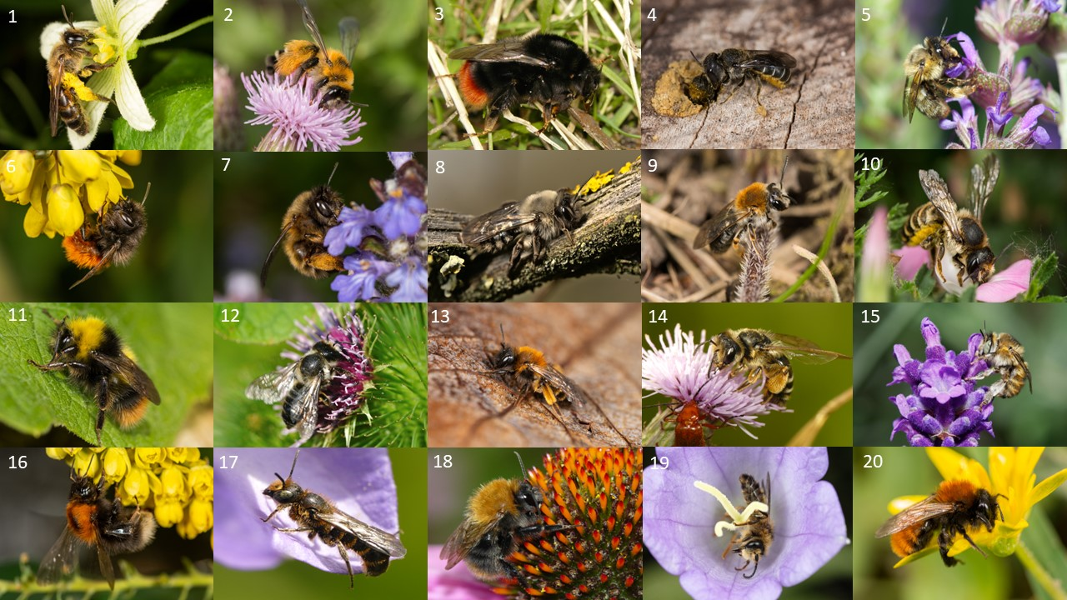
Figure S2: top 20 bees for the CS-dataset: 1. Andrena florea (Andrenidae), 2. Dasypoda hirtipes (Melittidae), 3. Bombus lapidarius (Apidae), 4. Heriades truncorum (Megachilidae), 5. Anthophora quadrimaculata (Apidae), 6. Osmia cornuta (Megachilidae), 7. Anthophora plumipes (Apidae), 8. Andrena vaga (Andrenidae), 9. Andrena haemorrhoa (Andrenidae), 10. Chalicodoma (Megachile) ericetorum (Megachilidae), 11. Bombus pratorum (Apidae), 12. Megachile willughbiella (Megachilidae), 13. Andrena bicolor (Andrenidae), 14. Andrena flavipes (Andrenidae), 15. Anthophora furcata (Apidae), 16. Bombus hypnorum (Apidae), 17. Chelostoma rapunculi (Megachilidae), 18. Bombus pascuorum (Apidae), 19. Melitta haemorrhoidalis (Melittidae), 20. Andrena fulva (Andrenidae). All photos © J Visser, except 1, 5, and 15 © NJ Vereecken.

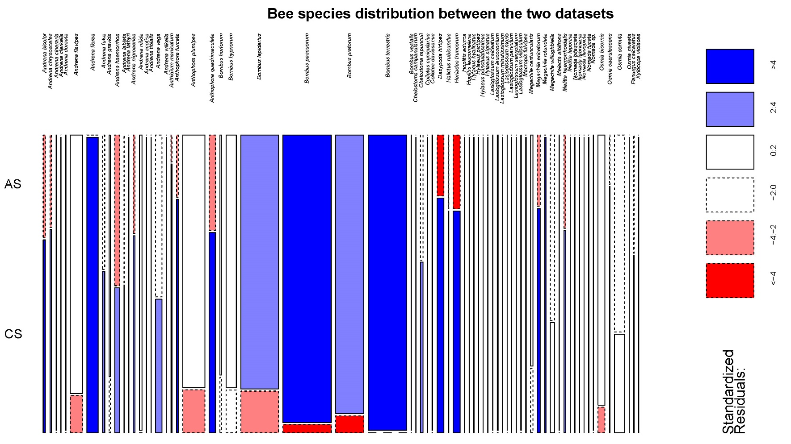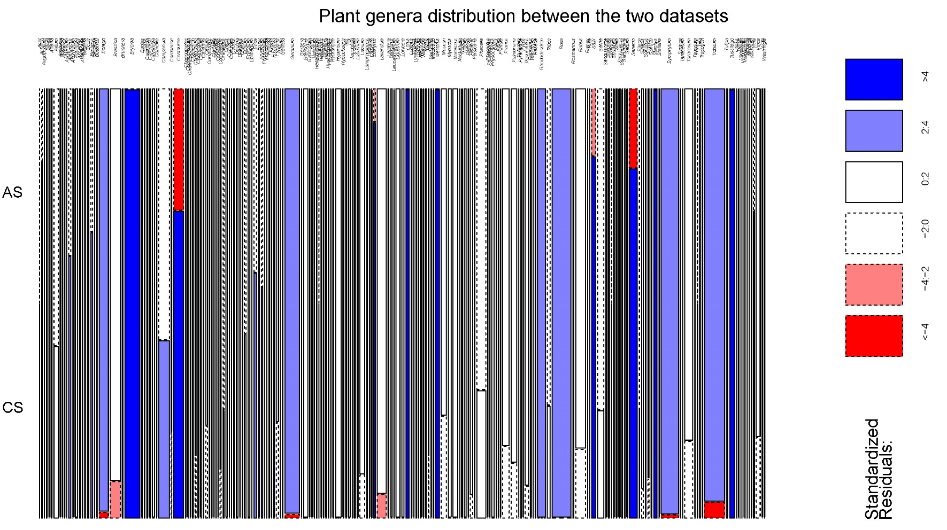
Figure S3: mosaic plots for the difference between the datasets in bee species (top) and plant genera (bottom). Blue lines indicate this species or genus is more found in the AS-dataset and the red lines indicate this species or genus is found more in the CS-dataset. Thickness of the line indicates the overall abundance.
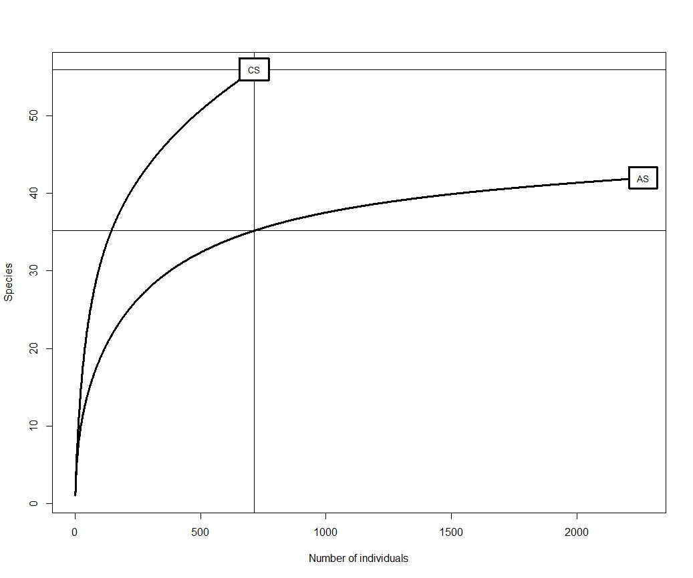
Figure S4: rarefaction curve of the number of species in function of the number of individuals for the AS-dataset and the CS-dataset. Curves show good sampling effort for both datasets.

Table S1: full list of all bee species and plant genera for the CS-dataset with the bee abundance per plant genus.
Bee species | Plant genus | Bee abundance per plant genus
Andrena bicolor | Bryonia | 2
Andrena bicolor | Campanula | 5
Andrena bicolor | Centaurea | 1
Andrena bicolor | Salix | 1
Andrena bicolor | Saxifraga | 1
Andrena bicolor | Tussilago | 5
Andrena chrysosceles | Aegopodium | 1
Andrena chrysosceles | Anthriscus | 8
Andrena chrysosceles | Pyracantha | 1
Andrena chrysosceles | Taraxacum | 1
Andrena clarkella | Salix | 2
Andrena flavipes | Achillea | 5
Andrena flavipes | Brassica | 1
Andrena flavipes | Centaurea | 1
Andrena flavipes | Hesperis | 1
Andrena flavipes | Knautia | 1
Andrena flavipes | Leucanthemum | 1
Andrena flavipes | Malva | 1
Andrena flavipes | Prunus | 2
Andrena flavipes | Taraxacum | 1
Andrena flavipes | Tussilago | 1
Andrena florea | Bryonia | 112
Andrena fulva | Buxus | 2
Andrena fulva | Prunus | 5
Andrena fulva | Ribes | 2
Andrena fulva | Salix | 1
Andrena fulva | Taraxacum | 1
Andrena fulva | Tussilago | 1
Andrena gravida | Anthriscus | 1
Andrena gravida | Taraxacum | 1
Andrena haemorrhoa | Brassica | 1
Andrena haemorrhoa | Cotoneaster | 1
Andrena haemorrhoa | Crataegus | 1
Andrena haemorrhoa | Fallopia | 5
Andrena haemorrhoa | Pyracantha | 1
Andrena haemorrhoa | Salix | 14
Andrena haemorrhoa | Ulmus | 1
Andrena labiata | Erysimum | 1
Andrena lathyri | Securigera | 1
Andrena nigroaenea | Allium | 1
Andrena nigroaenea | Bryonia | 4
Andrena nigroaenea | Buxus | 1
Andrena nigroaenea | Cardamine | 1
Andrena nigroaenea | Erysimum | 4
Andrena nigroaenea | Tussilago | 1
Andrena scotica | Bryonia | 1
Andrena tibialis | Prunus | 1
Andrena tibialis | Pyracantha | 1
Andrena tibialis | Taraxacum | 1
Andrena vaga | Acer | 1
Andrena vaga | Salix | 2
Andrena vaga | Tussilago | 25
Andrena wilkella | Trifolium | 1
Anthidium manicatum | Salvia | 1
Anthidium manicatum | Stachys | 9
Anthophora furcata | Convolvulus | 1
Anthophora furcata | Digitalis | 1
Anthophora furcata | Lavandula | 1
Anthophora furcata | Salvia | 1
Anthophora furcata | Stachys | 11
Anthophora plumipes | Berberis | 8
Anthophora plumipes | Brassica | 2
Anthophora plumipes | Centaurea | 1
Anthophora plumipes | Chelidonium | 1
Anthophora plumipes | Crataegus | 1
Anthophora plumipes | Cytisus | 1
Anthophora plumipes | Echium | 1
Anthophora plumipes | Erysimum | 2
Anthophora plumipes | Fragaria | 1
Anthophora plumipes | Lamium | 1
Anthophora plumipes | Pulmonaria | 5
Anthophora plumipes | Ribes | 2
Anthophora plumipes | Vicia | 1
Anthophora plumipes | Vinca | 5
Anthophora quadrimaculata | Allium | 5
Anthophora quadrimaculata | Echium | 1
Anthophora quadrimaculata | Lavandula | 2
Anthophora quadrimaculata | Lotus | 5
Anthophora quadrimaculata | Medicago | 3
Anthophora quadrimaculata | Phacelia | 22
Anthophora quadrimaculata | Stachys | 3
Anthophora quadrimaculata | Thymus | 1
Bombus hortorum | Digitalis | 1
Bombus hortorum | Salvia | 1
Bombus hortorum | Silene | 1
Bombus hypnorum | Centaurea | 1
Bombus hypnorum | Erica | 1
Bombus hypnorum | Knautia | 1
Bombus hypnorum | Lathraea | 1
Bombus hypnorum | Rubus | 10
Bombus hypnorum | Sorbus | 1
Bombus lapidarius | Allium | 7
Bombus lapidarius | Borago | 1
Bombus lapidarius | Centaurea | 4
Bombus lapidarius | Cirsium | 1
Bombus lapidarius | Corydalis | 1
Bombus lapidarius | Knautia | 1
Bombus lapidarius | Lamium | 1
Bombus lapidarius | Melilotus | 30
Bombus lapidarius | Papaver | 1
Bombus lapidarius | Senecio | 1
Bombus lapidarius | Trifolium | 4
Bombus lapidarius | Tussilago | 1
Bombus pascuorum | Echium | 1
Bombus pascuorum | Lamium | 2
Bombus pascuorum | Pulmonaria | 1
Bombus pascuorum | Ribes | 1
Bombus pascuorum | Salvia | 1
Bombus pascuorum | Stachys | 1
Bombus pascuorum | Symphytum | 1
Bombus pascuorum | Tussilago | 1
Bombus pascuorum | Vaccinium | 1
Bombus pascuorum | Vicia | 3
Bombus pratorum | Cirsium | 1
Bombus pratorum | Fragaria | 3
Bombus pratorum | Knautia | 1
Bombus pratorum | Ribes | 1
Bombus pratorum | Rubus | 3
Bombus pratorum | Salix | 1
Bombus pratorum | Scrophularia | 5
Bombus pratorum | Vinca | 1
Chelostoma campanularum | Campanula | 1
Chelostoma rapunculi | Campanula | 6
Chelostoma rapunculi | Digitalis | 1
Chelostoma rapunculi | Knautia | 1
Chelostoma rapunculi | Lythrum | 1
Chelostoma rapunculi | Salvia | 6
Colletes cunicularius | Salix | 1
Dasypoda hirtipes | Centaurea | 50
Dasypoda hirtipes | Jacobaea | 1
Dasypoda hirtipes | Knautia | 1
Dasypoda hirtipes | Senecio | 2
Halictus rubicundus | Anthriscus | 1
Halictus rubicundus | Brassica | 1
Halictus rubicundus | Taraxacum | 1
Heriades truncorum | Helianthus | 1
Heriades truncorum | Senecio | 50
Hoplitis adunca | Echium | 1
Hoplitis leucomelana | Lotus | 3
Hylaeus hyalinatus | Reseda | 1
Hylaeus hyalinatus | Verbascum | 2
Hylaeus pictipes | Brassica | 1
Hylaeus punctulatissimus | Allium | 1
Hylaeus signatus | Cirsium | 1
Hylaeus signatus | Reseda | 4
Lasioglossum minutissimum | Brassica | 1
Lasioglossum parvulum | Anthriscus | 1
Lasioglossum sexnotatum | Bryonia | 3
Macropis fulvipes | Geranium | 1
Macropis fulvipes | Lysimachia | 4
Macropis fulvipes | Prunus | 1
Megachile centuncularis | Cytisus | 1
Megachile centuncularis | Echium | 2
Megachile centuncularis | Knautia | 1
Megachile centuncularis | Lotus | 1
Megachile ericetorum | Cytisus | 4
Megachile ericetorum | Lathyrus | 12
Megachile ericetorum | Lavandula | 1
Megachile ericetorum | Salvia | 2
Megachile ericetorum | Securigera | 3
Megachile rotundata | Lotus | 11
Megachile willughbiella | Campanula | 11
Megachile willughbiella | Cytisus | 1
Megachile willughbiella | Lotus | 4
Melitta haemorrhoidalis | Campanula | 13
Melitta leporina | Trifolium | 1
Nomada bifasciata | Taraxacum | 2
Nomada fabriciana | Buxus | 1
Nomada flavopicta | Rumex | 1
Nomada fucata | Taraxacum | 4
Osmia bicornis | Knautia | 1
Osmia bicornis | Ranunculus | 1
Osmia bicornis | Sinapis | 1
Osmia bicornis | Stachys | 2
Osmia bicornis | Vicia | 1
Osmia caerulescens | Bryonia | 1
Osmia caerulescens | Lotus | 3
Osmia caerulescens | Medicago | 1
Osmia cornuta | Berberis | 2
Osmia cornuta | Erica | 11
Osmia cornuta | Muscari | 10
Osmia cornuta | Salix | 5
Osmia cornuta | Tussilago | 6
Osmia niveata | Knautia | 1
Panurgus calcaratus | Asteraceae | 2
Panurgus calcaratus | Ranunculus | 1
Xylocopa violacea | Salvia | 1

Table S2: full list of all bee species and plant genera for the AS-dataset with the bee abundance per plant genus.
Bee species | Plant genus | Bee abundance per plant genus
Andrena bicolor | Campanula | 1
Andrena bicolor | Ficaria | 1
Andrena bicolor | Gerbera | 1
Andrena bicolor | Muscari | 1
Andrena bicolor | Myosotis | 1
Andrena bicolor | Narcissus | 1
Andrena bicolor | Prunus | 1
Andrena bicolor | Taraxacum | 1
Andrena chrysosceles | Cornus | 2
Andrena chrysosceles | Ribes | 1
Andrena chrysosceles | Syringa | 1
Andrena chrysosceles | Tulipa | 1
Andrena cineraria | Euphorbia | 1
Andrena cineraria | Fragaria | 1
Andrena cineraria | Narcissus | 1
Andrena cineraria | Taraxacum | 1
Andrena dorsata | Anthriscus | 1
Andrena dorsata | Bellis | 1
Andrena dorsata | Crataegus | 1
Andrena dorsata | Erica | 1
Andrena dorsata | Nigella | 1
Andrena flavipes | Alliaria | 1
Andrena flavipes | Anthemis | 2
Andrena flavipes | Anthriscus | 1
Andrena flavipes | Berberis | 1
Andrena flavipes | Bergenia | 1
Andrena flavipes | Borago | 1
Andrena flavipes | Brassica | 4
Andrena flavipes | Brunnera | 3
Andrena flavipes | Bunias | 4
Andrena flavipes | Calendula | 1
Andrena flavipes | Centaurea | 1
Andrena flavipes | Cineraria | 2
Andrena flavipes | Cirsium | 2
Andrena flavipes | Cotoneaster | 1
Andrena flavipes | Crataegus | 1
Andrena flavipes | Echium | 1
Andrena flavipes | Epilobium | 2
Andrena flavipes | Erica | 2
Andrena flavipes | Erysimum | 1
Andrena flavipes | Forsythia | 4
Andrena flavipes | Fragaria | 1
Andrena flavipes | Geranium | 2
Andrena flavipes | Hypericum | 1
Andrena flavipes | Hypochaeris | 3
Andrena flavipes | Lamprocapnos | 1
Andrena flavipes | Lapsana | 1
Andrena flavipes | ligustrum | 14
Andrena flavipes | Mahonia | 1
Andrena flavipes | Muscari | 5
Andrena flavipes | Narcissus | 3
Andrena flavipes | Nigella | 2
Andrena flavipes | Prunus | 2
Andrena flavipes | Ranunculus | 2
Andrena flavipes | Raphanus | 1
Andrena flavipes | Rapistrum | 1
Andrena flavipes | Rhododendron | 2
Andrena flavipes | Ribes | 3
Andrena flavipes | Rosa | 1
Andrena flavipes | Senecio | 3
Andrena flavipes | Sinapis | 5
Andrena flavipes | Symphytum | 1
Andrena flavipes | Taraxacum | 5
Andrena flavipes | Trifolium | 3
Andrena flavipes | Tulipa | 3
Andrena flavipes | Vinca | 3
Andrena fulva | Acer | 1
Andrena fulva | Erica | 1
Andrena fulva | Lamium | 1
Andrena fulva | Physocarpus | 3
Andrena fulva | Prunus | 1
Andrena fulva | Sorbus | 2
Andrena fulva | Viola | 1
Andrena gravida | Fragaria | 1
Andrena gravida | Helenium | 1
Andrena gravida | Hyacinthus | 1
Andrena gravida | Prunus | 1
Andrena gravida | Ranunculus | 1
Andrena gravida | Taraxacum | 2
Andrena gravida | Vinca | 2
Andrena haemorrhoa | Anthriscus | 1
Andrena haemorrhoa | Camellia | 1
Andrena haemorrhoa | Campanula | 1
Andrena haemorrhoa | Crataegus | 1
Andrena haemorrhoa | Geranium | 1
Andrena haemorrhoa | Glechoma | 1
Andrena haemorrhoa | Muscari | 1
Andrena haemorrhoa | Physocarpus | 6
Andrena haemorrhoa | Prunus | 3
Andrena haemorrhoa | Rosa | 3
Andrena haemorrhoa | Sorbus | 2
Andrena haemorrhoa | Syringa | 1
Andrena haemorrhoa | Taraxacum | 2
Andrena haemorrhoa | Tulipa | 1
Andrena labiata | Myosotis | 1
Andrena nigroaenea | Brassica | 1
Andrena nigroaenea | Cardamine | 1
Andrena nigroaenea | Fragaria | 1
Andrena nigroaenea | Prunus | 1
Andrena nigroaenea | Rosa | 1
Andrena nigroaenea | Taraxacum | 1
Andrena nitida | Allium | 1
Andrena nitida | Anthriscus | 1
Andrena nitida | Bellis | 1
Andrena nitida | Bunias | 1
Andrena nitida | Camellia | 2
Andrena nitida | Crataegus | 1
Andrena nitida | Eruca | 1
Andrena nitida | Geranium | 2
Andrena nitida | Glechoma | 2
Andrena nitida | Hyacinthoides | 1
Andrena nitida | Narcissus | 1
Andrena nitida | Physocarpus | 1
Andrena nitida | Saxifraga | 1
Andrena nitida | sorbus | 2
Andrena nitida | Sorbus | 2
Andrena nitida | Taraxacum | 4
Andrena nitida | Tulipa | 1
Andrena vaga | Anthriscus | 1
Andrena vaga | Bellis | 4
Andrena vaga | Cardamine | 1
Andrena vaga | Cornus | 1
Andrena vaga | Erica | 1
Andrena vaga | Ficaria | 1
Andrena vaga | Ilex | 5
Andrena vaga | Magnolia | 2
Andrena vaga | Muscari | 1
Andrena vaga | Myosotis | 1
Andrena vaga | Narcissus | 3
Andrena vaga | Prunus | 10
Andrena vaga | Taraxacum | 3
Anthidium manicatum | Leonurus | 1
Anthophora furcata | Iris | 1
Anthophora furcata | Lavandula | 1
Anthophora furcata | Teucrium | 2
Anthophora plumipes | Ajuga | 1
Anthophora plumipes | Bellis | 1
Anthophora plumipes | Berberis | 2
Anthophora plumipes | Brassica | 11
Anthophora plumipes | Brunnera | 1
Anthophora plumipes | Chionodoxa | 3
Anthophora plumipes | Corylopsis | 1
Anthophora plumipes | Erica | 1
Anthophora plumipes | Eruca | 4
Anthophora plumipes | Erysimum | 3
Anthophora plumipes | Erythronium | 1
Anthophora plumipes | Geranium | 14
Anthophora plumipes | Glechoma | 12
Anthophora plumipes | Hyacinthus | 1
Anthophora plumipes | Ilex | 1
Anthophora plumipes | Laburnum | 3
Anthophora plumipes | Lamium | 25
Anthophora plumipes | Lamprocapnos | 4
Anthophora plumipes | Lonicera | 1
Anthophora plumipes | Magnolia | 1
Anthophora plumipes | Malus | 1
Anthophora plumipes | Muscari | 3
Anthophora plumipes | Myosotis | 4
Anthophora plumipes | Narcissus | 20
Anthophora plumipes | Nasturtium | 1
Anthophora plumipes | Pieris | 1
Anthophora plumipes | Primula | 1
Anthophora plumipes | Prunus | 5
Anthophora plumipes | Pulmonaria | 10
Anthophora plumipes | Rhododendron | 7
Anthophora plumipes | Ribes | 5
Anthophora plumipes | Salix | 1
Anthophora plumipes | Salvia | 4
Anthophora plumipes | Silene | 1
Anthophora plumipes | Spiraea | 1
Anthophora plumipes | Stellaria | 1
Anthophora plumipes | Symphytum | 15
Anthophora plumipes | Thymus | 1
Anthophora plumipes | Vinca | 16
Anthophora quadrimaculata | Borago | 1
Anthophora quadrimaculata | Campanula | 1
Anthophora quadrimaculata | Echium | 4
Anthophora quadrimaculata | Geranium | 1
Anthophora quadrimaculata | Lavandula | 5
Anthophora quadrimaculata | Phacelia | 3
Anthophora quadrimaculata | Salvia | 5
Bombus hortorum | Geranium | 1
Bombus hortorum | Lavandula | 1
Bombus hortorum | Rosa | 1
Bombus hortorum | Salvia | 10
Bombus hypnorum | Anthericum | 1
Bombus hypnorum | Borago | 1
Bombus hypnorum | Calystegia | 1
Bombus hypnorum | Campanula | 3
Bombus hypnorum | Chelidonium | 3
Bombus hypnorum | Deutzia | 4
Bombus hypnorum | Epilobium | 2
Bombus hypnorum | Fragaria | 1
Bombus hypnorum | Glechoma | 2
Bombus hypnorum | Hebe | 1
Bombus hypnorum | Heuchera | 1
Bombus hypnorum | Lonicera | 1
Bombus hypnorum | Malus | 2
Bombus hypnorum | Phacelia | 7
Bombus hypnorum | Ribes | 1
Bombus hypnorum | Rosa | 26
Bombus hypnorum | Rubus | 17
Bombus hypnorum | Salix | 1
Bombus hypnorum | Sanguisorba | 2
Bombus hypnorum | Symphytum | 6
Bombus hypnorum | Taraxacum | 2
Bombus hypnorum | Trifolium | 3
Bombus hypnorum | Valerianella | 1
Bombus lapidarius | Allium | 14
Bombus lapidarius | Angelica | 1
Bombus lapidarius | Asclepias | 3
Bombus lapidarius | Baptisia | 2
Bombus lapidarius | Bellis | 1
Bombus lapidarius | Borago | 8
Bombus lapidarius | Brassica | 15
Bombus lapidarius | Campanula | 23
Bombus lapidarius | Centaurea | 15
Bombus lapidarius | Chionodoxa | 1
Bombus lapidarius | Cichorium | 5
Bombus lapidarius | Cirsium | 6
Bombus lapidarius | Cotoneaster | 5
Bombus lapidarius | Dianthus | 1
Bombus lapidarius | Eruca | 2
Bombus lapidarius | Fragaria | 1
Bombus lapidarius | Geranium | 6
Bombus lapidarius | Gypsophila | 1
Bombus lapidarius | Helianthemum | 2
Bombus lapidarius | Heuchera | 1
Bombus lapidarius | hypericum | 7
Bombus lapidarius | Hypericum | 12
Bombus lapidarius | Hypochaeris | 2
Bombus lapidarius | Lamium | 3
Bombus lapidarius | Lapsana | 1
Bombus lapidarius | Lavandula | 1
Bombus lapidarius | Lavatera | 1
Bombus lapidarius | Ligustrum | 2
Bombus lapidarius | Lupinus | 3
Bombus lapidarius | Magnolia | 2
Bombus lapidarius | Malva | 2
Bombus lapidarius | Myosotis | 1
Bombus lapidarius | Narcissus | 1
Bombus lapidarius | Nigella | 3
Bombus lapidarius | Papaver | 5
Bombus lapidarius | Persicaria | 2
Bombus lapidarius | Phacelia | 5
Bombus lapidarius | Philadelphus | 1
Bombus lapidarius | Physocarpus | 9
Bombus lapidarius | Pulsatilla | 1
Bombus lapidarius | Ranunculus | 5
Bombus lapidarius | Raphanus | 4
Bombus lapidarius | Rosa | 18
Bombus lapidarius | Rubus | 3
Bombus lapidarius | Ruta | 2
Bombus lapidarius | Salvia | 3
Bombus lapidarius | Scabiosa | 3
Bombus lapidarius | Sedum | 2
Bombus lapidarius | Senecio | 8
Bombus lapidarius | Sinapis | 8
Bombus lapidarius | Symphytum | 1
Bombus lapidarius | Taraxacum | 3
Bombus lapidarius | Tilia | 1
Bombus lapidarius | Trifolium | 83
Bombus lapidarius | Viburnum | 1
Bombus lapidarius | Westringia | 2
Bombus pascuorum | Ajuga | 4
Bombus pascuorum | Alcea | 1
Bombus pascuorum | Alliaria | 3
Bombus pascuorum | Allium | 1
Bombus pascuorum | Anchusa | 1
Bombus pascuorum | Anthriscus | 1
Bombus pascuorum | Antirrhinum | 3
Bombus pascuorum | Aquilegia | 1
Bombus pascuorum | Asclepias | 5
Bombus pascuorum | Baptisia | 2
Bombus pascuorum | Betonica | 4
Bombus pascuorum | Borago | 5
Bombus pascuorum | Brassica | 6
Bombus pascuorum | Brunnera | 1
Bombus pascuorum | Callicarpa | 2
Bombus pascuorum | Calystegia | 10
Bombus pascuorum | Campanula | 1
Bombus pascuorum | Chaenomeles | 1
Bombus pascuorum | chamerion | 1
Bombus pascuorum | Chelidonium | 1
Bombus pascuorum | Cineraria | 1
Bombus pascuorum | Cirsium | 1
Bombus pascuorum | Coronilla | 1
Bombus pascuorum | Echium | 3
Bombus pascuorum | Epilobium | 3
Bombus pascuorum | Erysimum | 2
Bombus pascuorum | Fragaria | 3
Bombus pascuorum | Genista | 1
Bombus pascuorum | Geranium | 45
Bombus pascuorum | Glechoma | 8
Bombus pascuorum | Helianthemum | 1
Bombus pascuorum | Helleborus | 2
Bombus pascuorum | Heuchera | 1
Bombus pascuorum | Hyacinthoides | 1
Bombus pascuorum | hypericum | 4
Bombus pascuorum | Hypericum | 6
Bombus pascuorum | Iris | 8
Bombus pascuorum | Laburnum | 2
Bombus pascuorum | lamium | 1
Bombus pascuorum | Lamium | 5
Bombus pascuorum | Lamprocapnos | 2
Bombus pascuorum | Lavandula | 29
Bombus pascuorum | Lavatera | 1
Bombus pascuorum | Leonurus | 10
Bombus pascuorum | Ligustrum | 13
Bombus pascuorum | Lonicera | 1
Bombus pascuorum | Lychnis | 1
Bombus pascuorum | Malus | 1
Bombus pascuorum | Muscari | 1
Bombus pascuorum | Myosotis | 4
Bombus pascuorum | Narcissus | 3
Bombus pascuorum | Nepeta | 4
Bombus pascuorum | Nigella | 3
Bombus pascuorum | Phacelia | 4
Bombus pascuorum | Phaseolus | 1
Bombus pascuorum | Pisum | 2
Bombus pascuorum | Pulmonaria | 21
Bombus pascuorum | Pyrus | 1
Bombus pascuorum | Ranunculus | 3
Bombus pascuorum | rhododendron | 9
Bombus pascuorum | Rhododendron | 16
Bombus pascuorum | Ribes | 1
Bombus pascuorum | Rosa | 53
Bombus pascuorum | Rosmarinus | 2
Bombus pascuorum | Rubus | 13
Bombus pascuorum | Salix | 1
Bombus pascuorum | Salvia | 8
Bombus pascuorum | Scabiosa | 2
Bombus pascuorum | Scilla | 2
Bombus pascuorum | Sedum | 1
Bombus pascuorum | Silene | 1
Bombus pascuorum | Sinapis | 1
Bombus pascuorum | Spiraea | 1
Bombus pascuorum | Symphytum | 35
Bombus pascuorum | Taraxacum | 11
Bombus pascuorum | Teucrium | 1
Bombus pascuorum | Tilia | 1
Bombus pascuorum | Trifolium | 46
Bombus pascuorum | Urtica | 1
Bombus pascuorum | Verbena | 1
Bombus pascuorum | Veronica | 2
Bombus pascuorum | Vinca | 3
Bombus pratorum | Allium | 4
Bombus pratorum | Aquilegia | 12
Bombus pratorum | Asclepias | 1
Bombus pratorum | Borago | 20
Bombus pratorum | Brassica | 3
Bombus pratorum | Calystegia | 1
Bombus pratorum | Campanula | 7
Bombus pratorum | Chaenomeles | 3
Bombus pratorum | Chelidonium | 1
Bombus pratorum | Cornus | 1
Bombus pratorum | Crataegus | 1
Bombus pratorum | Deutzia | 8
Bombus pratorum | Epilobium | 4
Bombus pratorum | Epimedium | 1
Bombus pratorum | Geranium | 15
Bombus pratorum | Glechoma | 8
Bombus pratorum | Helleborus | 1
Bombus pratorum | Heuchera | 3
Bombus pratorum | Iris | 4
Bombus pratorum | Lavandula | 6
Bombus pratorum | Lavatera | 3
Bombus pratorum | Ligustrum | 1
Bombus pratorum | Lonicera | 14
Bombus pratorum | Malus | 1
Bombus pratorum | Malva | 2
Bombus pratorum | Myosotis | 1
Bombus pratorum | Phacelia | 16
Bombus pratorum | Physocarpus | 2
Bombus pratorum | Prunus | 2
Bombus pratorum | Pulmonaria | 9
Bombus pratorum | Ranunculus | 4
Bombus pratorum | rhododendron | 2
Bombus pratorum | Rhododendron | 3
Bombus pratorum | Ribes | 2
Bombus pratorum | Rosa | 10
Bombus pratorum | Rosmarinus | 1
Bombus pratorum | Rubus | 27
Bombus pratorum | Salix | 2
Bombus pratorum | Salvia | 2
Bombus pratorum | Satureja | 10
Bombus pratorum | Sorbus | 1
Bombus pratorum | Symphytum | 31
Bombus pratorum | Taraxacum | 11
Bombus pratorum | Tilia | 1
Bombus pratorum | Trapogon | 1
Bombus pratorum | Trifolium | 1
Bombus pratorum | Urtica | 1
Bombus pratorum | Westringia | 1
Bombus terrestris | Allium | 1
Bombus terrestris | Anthriscus | 1
Bombus terrestris | Aquilegia | 6
Bombus terrestris | Baptisia | 1
Bombus terrestris | Berberis | 1
Bombus terrestris | Borago | 27
Bombus terrestris | Brassica | 30
Bombus terrestris | Calendula | 1
Bombus terrestris | Callicarpa | 5
Bombus terrestris | Calystegia | 4
Bombus terrestris | Campanula | 1
Bombus terrestris | Centaurea | 5
Bombus terrestris | Chamaespartium | 1
Bombus terrestris | chamerion | 1
Bombus terrestris | Chelidonium | 1
Bombus terrestris | Cirsium | 1
Bombus terrestris | Cotoneaster | 2
Bombus terrestris | crataegus | 1
Bombus terrestris | Cucurbita | 2
Bombus terrestris | Deutzia | 2
Bombus terrestris | Dianthus | 1
Bombus terrestris | Erica | 2
Bombus terrestris | Fragaria | 3
Bombus terrestris | Galium | 1
Bombus terrestris | Geranium | 5
Bombus terrestris | Hebe | 3
Bombus terrestris | Helianthemum | 1
Bombus terrestris | Helleborus | 2
Bombus terrestris | Hydrangea | 6
Bombus terrestris | hypericum | 2
Bombus terrestris | Hypericum | 13
Bombus terrestris | Ilex | 1
Bombus terrestris | Laburnum | 2
Bombus terrestris | Lavandula | 22
Bombus terrestris | Lavatera | 1
Bombus terrestris | Ligustrum | 2
Bombus terrestris | Lupinus | 3
Bombus terrestris | Lychnis | 1
Bombus terrestris | Malva | 1
Bombus terrestris | Muscari | 2
Bombus terrestris | Myosotis | 2
Bombus terrestris | Narcissus | 3
Bombus terrestris | Nigella | 6
Bombus terrestris | paeonia | 2
Bombus terrestris | Papaver | 13
Bombus terrestris | Phacelia | 16
Bombus terrestris | Pieris | 1
Bombus terrestris | Prunus | 7
Bombus terrestris | Pulmonaria | 1
Bombus terrestris | Ranunculus | 1
Bombus terrestris | rhododendron | 6
Bombus terrestris | Rhododendron | 10
Bombus terrestris | Ribes | 3
Bombus terrestris | Rosa | 38
Bombus terrestris | Rosmarinus | 2
Bombus terrestris | Rubus | 6
Bombus terrestris | Salvia | 3
Bombus terrestris | Sanguisorba | 2
Bombus terrestris | Scorzonera | 2
Bombus terrestris | Sedum | 1
Bombus terrestris | Senecio | 1
Bombus terrestris | Sorbus | 1
Bombus terrestris | Spiraea | 5
Bombus terrestris | Stellaria | 1
Bombus terrestris | Symphytum | 47
Bombus terrestris | Teucrium | 1
Bombus terrestris | Tilia | 7
Bombus terrestris | Trifolium | 21
Bombus terrestris | Tulipa | 1
Bombus terrestris | Viburnum | 1
Bombus terrestris | Vicia | 2
Bombus terrestris | Vinca | 2
Bombus terrestris | Westringia | 1
Bombus vestalis | Heuchera | 1
Bombus vestalis | rhododendron | 1
Bombus vestalis | Rubus | 1
Chelostoma rapunculi | Brassica | 1
Chelostoma rapunculi | Campanula | 3
Chelostoma rapunculi | Geranium | 3
Chelostoma rapunculi | Salvia | 3
Chelostoma rapunculi | Silene | 1
Colletes daviesanus | Achillea | 1
Colletes daviesanus | Chamaemelum | 2
Colletes daviesanus | Matricaria | 2
Colletes daviesanus | Tanacetum | 2
Dasypoda hirtipes | Calendula | 2
Dasypoda hirtipes | Centaurea | 2
Dasypoda hirtipes | Cirsium | 1
Dasypoda hirtipes | Crepis | 5
Dasypoda hirtipes | Geranium | 2
Dasypoda hirtipes | Scorzonera | 2
Halictus rubicundus | Cardamine | 1
Heriades truncorum | Anthemis | 2
Heriades truncorum | Calendula | 3
Heriades truncorum | Crepis | 1
Heriades truncorum | Cucumis | 1
Heriades truncorum | Helenium | 1
Heriades truncorum | Helianthus | 1
Heriades truncorum | Hypochaeris | 1
Heriades truncorum | Matricaria | 1
Heriades truncorum | Ranunculus | 1
Heriades truncorum | Sonchus | 4
Heriades truncorum | Taraxacum | 1
Lasioglossum calceatum | Ranunculus | 1
Lasioglossum calceatum | Taraxacum | 1
Lasioglossum calceatum | Tulipa | 1
Lasioglossum leucozonium | Calendula | 1
Lasioglossum leucozonium | Crepis | 3
Lasioglossum leucozonium | Scorzonera | 4
Lasioglossum morio | Raphanus | 1
Lasioglossum villosulum | Crepis | 1
Lasioglossum villosulum | Scorzonera | 1
Lasioglossum villosulum | Taraxacum | 1
Megachile centuncularis | Borago | 5
Megachile centuncularis | Cineraria | 1
Megachile centuncularis | Epilobium | 1
Megachile centuncularis | Geranium | 5
Megachile centuncularis | Helenium | 1
Megachile centuncularis | Hypericum | 1
Megachile centuncularis | Hypochaeris | 1
Megachile centuncularis | Malva | 1
Megachile centuncularis | Rubus | 1
Megachile centuncularis | Symphytum | 1
Megachile ericetorum | Baptisia | 1
Megachile ericetorum | Genista | 1
Megachile ericetorum | Geranium | 1
Megachile ericetorum | Lathyrus | 1
Megachile ericetorum | Lavandula | 3
Megachile willughbiella | Baptisia | 1
Megachile willughbiella | Borago | 2
Megachile willughbiella | Campanula | 4
Megachile willughbiella | Chamaespartium | 1
Megachile willughbiella | chamerion | 5
Megachile willughbiella | Epilobium | 4
Megachile willughbiella | Genista | 2
Megachile willughbiella | Geranium | 2
Megachile willughbiella | Rhododendron | 2
Megachile willughbiella | Rosa | 3
Megachile willughbiella | Salvia | 1
Melecta albifrons | Euphorbia | 1
Melecta albifrons | Rhododendron | 2
Melecta albifrons | Rosmarinus | 1
Melitta haemorrhoidalis | Borago | 1
Melitta haemorrhoidalis | Campanula | 2
Melitta haemorrhoidalis | Geranium | 3
Nomada sp. | Cardamine | 1
Nomada sp. | Glechoma | 1
Osmia bicornis | Ajuga | 1
Osmia bicornis | Alliaria | 4
Osmia bicornis | Borago | 4
Osmia bicornis | Brassica | 1
Osmia bicornis | Forsythia | 1
Osmia bicornis | Fragaria | 2
Osmia bicornis | Geranium | 12
Osmia bicornis | Malus | 1
Osmia bicornis | Muscari | 4
Osmia bicornis | Myosotis | 7
Osmia bicornis | Nepeta | 2
Osmia bicornis | Phacelia | 1
Osmia bicornis | Prunus | 2
Osmia bicornis | Ranunculus | 7
Osmia bicornis | Rhododendron | 4
Osmia bicornis | Rosa | 1
Osmia bicornis | Scilla | 1
Osmia bicornis | Symphytum | 3
Osmia bicornis | Taraxacum | 5
Osmia bicornis | Trifolium | 1
Osmia caerulescens | Lavandula | 1
Osmia cornuta | Bellis | 5
Osmia cornuta | Berberis | 1
Osmia cornuta | Bergenia | 1
Osmia cornuta | Brassica | 3
Osmia cornuta | Campanula | 4
Osmia cornuta | Chionodoxa | 4
Osmia cornuta | Cornus | 1
Osmia cornuta | Erica | 1
Osmia cornuta | Forsythia | 1
Osmia cornuta | Hyacinthoides | 1
Osmia cornuta | Lamium | 1
Osmia cornuta | Magnolia | 2
Osmia cornuta | Mahonia | 2
Osmia cornuta | Muscari | 14
Osmia cornuta | Myosotis | 1
Osmia cornuta | Narcissus | 3
Osmia cornuta | Prunus | 10
Osmia cornuta | Ribes | 1
Osmia cornuta | Rosmarinus | 1
Osmia cornuta | Scilla | 5
Osmia cornuta | Stellaria | 1
Osmia cornuta | Taraxacum | 1
Osmia cornuta | Tulipa | 3
Osmia cornuta | Viola | 1
Panurgus calcaratus | Calendula | 1
Panurgus calcaratus | Crepis | 1

