
Appendix to J Poll Ecol 38(9), Etter et al.
DOI: 10.26786/1920-7603(2025)837

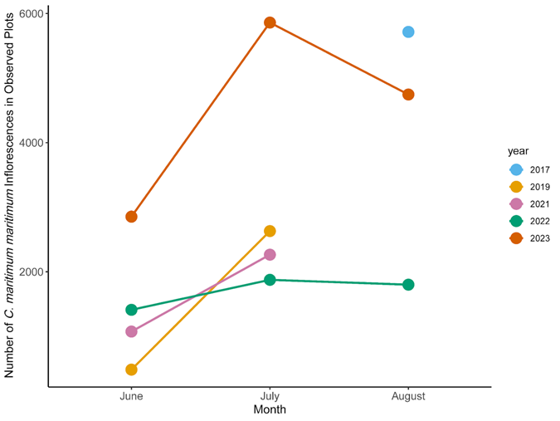
Figure A1. The number of Chloropyron maritimum ssp. maritimum inflorescence available for pollinators in observed plots by month and year. In 2017, the plots were only observed once in August after they were established. In 2019 and 2021, the plots were only observed in June and July.

