
Appendices to J Poll Ecol 39(17), Virkar et al.
DOI: 10.26786/1920-7603(2025)857

Table S1. Field study farm characteristics: Elevation (m); farm size (ha); number of apple trees; mean percentage of open flowers observed on one cluster on each on 10 apple trees for each orchard between 27 and 29 March, 2023; number and type of hives of Apis cerana; number, cultivar, and age of apple tree used in the pollination exclusion experiment (see Fraser et al. 2024); corresponding polliniser varieties used for hand pollination.

Farm code | Elevation  (m) | Farm size  (ha) | # apple trees | % open flowers | Managed hives of Apis cerana indica | # used and tree cultivar  (tree age in years) | Polliniser variety
Farm A | 1680 | 0.84 | 139 | 14.00% | None | 2 Fenny (30 yr)  7 Brown Delicious (5 yr)  1 Desi (n/a) | Red Delicious  Red Delicious  None
Farm B | 1701 | 0.06 | 40 | 95.57% | 1 wall hive | 3 Fenny (11)  7 Brown Delicious (11 yr) | Brown Delicious  Fenny
Farm C | 1744 | 0.06 | 170 | 48.90% | None | 10 Brown Delicious (3 yr) | Red Delicious
Farm D | 1900 | 0.20 | 100 | 97.17% | None | 2 Fenny (30 yr)  8 Brown Delicious (15 yr) | Brown Delicious  Fenny
Farm E | 1885 | 0.20 | 92 | 92.67% | None | 10 Brown Delicious (15 yr) | Fenny
Farm F | 1940 | 0.30 | 170 | 76.88% | None | 6 Fenny (30 yr)  4 Brown Delicious (6 yr) | Brown Delicious  Fenny
Farm HJ | 2055 | 0.50 | 98 | 85.21% | None | 7 Fenny (25 - 60 yr)  11 Brown Delicious (25 yr)  1 Red Delicious (30 yr)  1 ‘103’ (8 yr) | Red Delicious  Red Delicious and Fenny  Brown Delicious  Red Delicious
Farm K | 2125 | 3.01 | 476 | 86.25% | None | 6 Brown Delicious (20 yr)  1 Fenny (50 yr)  1 Full Branch (35 yr)  1 Winter (n/a)  1 ‘103’ (50 yr) | Red Delicious and Fenny  Red Delicious  Red Delicious  Brown Delicious
Farm L | 2138 | 0.66 | 84 | 67.00% | None | 7 Brown Delicious (n/a)  2 Fenny (50 yr)  1 ‘103’ (50 yr) | Fenny  Red Delicious  Fenny
Farm M | 2183 | 0.70 | 67 | 91.40% | None | 1 Brown Delicious (n/a)  5 Fenny (90 yr)  3 ‘103’ (n/a)  1 Winter (n/a) | Fenny  Red Delicious  Fenny  None
Farm N | 2197 | 2.01 | 982 | 71.33% | None | 10 Brown Delicious (25 yr) | Red Delicious
Farm PQ | 2241 | 0.30 | 167 | 83.23% | 2 boxes  4 wall hives | 20 Brown Delicious (15 yr) | Red Delicious  Hara Pichaula
Farm R | 2360 | 0.40 | 444 | 45.38% | 6 boxes  1 wall hive | 10 Brown Delicious (22 yr) | Red Delicious

Table S2. Date and number of intact pan and vane traps collected at each farm during each sampling event. Ten pan traps of each color and one vane trap were deployed on each farm during each sampling event unless otherwise noted (NA indicates no sampling was conducted on that date; -- indicates that no traps of the specified type were deployed). Six samples were collected on each farm except farm B, from which five samples were collected. Farms HJ and PQ are listed twice under each sampling date because one sample was collected from each of two adjacent farms (H and J, or P and Q). Before data were analyzed, the paired samples were merged because the farms were essentially contiguous (< 50 m apart).

 |  | Sampling method
Sample and Farm ID | Sampling date | Pan trap |  |  | Vane trap
Sample and Farm ID | Sampling date | Blue | Yellow | White | Vane trap
Sample 1 | Feb 5-9
Farm A | 9-Feb-2023 | 10 | 10 | 10 | 1
Farm B | 8-Feb-2023 | 10 | 10 | 9 | 1
Farm C | 9-Feb-2023 | 10 | 10 | 10 | 1
Farm D | 7-Feb-2023 | 10 | 10 | 10 | 0
Farm E | 7-Feb-2023 | 10 | 9 | 10 | 0
Farm F | 7-Feb-2023 | 8 | 9 | 7 | 0
Farm HJ | 8-Feb-2023 | 10 | 10 | 4 | 1
Farm HJ | 7-Feb-2023 | 10 | 10 | 10 | 1
Farm K | 6-Feb-2023 | 10 | 10 | 10 | 0
Farm L | 6-Feb-2023 | 10 | 10 | 10 | 0
Farm M | 6-Feb-2023 | 10 | 8 | 9 | 0
Farm N | 6-Feb-2023 | 10 | 10 | 10 | 0
Farm PQ | 5-Feb-2023 | 10 | 10 | 10 | 0
Farm PQ | 5-Feb-2023 | 10 | 10 | 10 | 0
Farm R | 5-Feb-2023 | 10 | 10 | 9 | 0
Sample 2 | Feb 16
Farm A | 16-Feb-2023 | 9 | 9 | 9 | 1
Farm B | 16-Feb-2023 | 10 | 9 | 10 | 1
Farm C | 16-Feb-2023 | 10 | 10 | 10 | 1
Farm D | 16-Feb-2023 | 10 | 10 | 10 | 1
Farm E | 16-Feb-2023 | 10 | 10 | 10 | 1
Farm F | 16-Feb-2023 | 10 | 10 | 7 | 1
Farm HJ | 16-Feb-2023 | 10 | 10 | 10 | 1
Farm HJ | 16-Feb-2023 | 10 | 10 | 10 | 1
Farm K | 16-Feb-2023 | 10 | 10 | 10 | --
Farm L | 16-Feb-2023 | 10 | 10 | 10 | 1
Farm M | 16-Feb-2023 | 10 | 9 | 10 | 1
Farm N | 16-Feb-2023 | 10 | 10 | 10 | 1
Farm PQ | 16-Feb-2023 | 9 | 10 | 9 | 1
Farm PQ | 16-Feb-2023 | 9 | 8 | 10 | 1
Farm R | 16-Feb-2023 | 10 | 10 | 10 | 1
Sample 3 | Mar 2-3
Farm A | 2-Mar-2023 | 10 | 10 | 9 | 1
Farm B | 2-Mar-2023 | 10 | 9 | 10 | 1
Farm C | 2-Mar-2023 | 10 | 10 | 10 | 1
Farm D | 2-Mar-2023 | 10 | 10 | 9 | 1
Farm E | 2-Mar-2023 | 10 | 10 | 10 | 1
Farm F | 2-Mar-2023 | 10 | 10 | 10 | 1
Farm HJ | 3-Mar-2023 | 10 | 10 | 10 | 1
Farm HJ | 3-Mar-2023 | 10 | 10 | 10 | 1
Farm K | 2-Mar-2023 | 10 | 10 | 10 | --
Farm L | 2-Mar-2023 | 10 | 10 | 10 | 1
Farm M | 2-Mar-2023 | 10 | 10 | 10 | 1
Farm N | 3-Mar-2023 | 9 | 9 | 10 | 1
Farm PQ | 2-Mar-2023 | 9 | 10 | 10 | 1
Farm PQ | 2-Mar-2023 | 10 | 9 | 9 | 1
Farm R | 2-Mar-2023 | 9 | 10 | 10 | 1
Sample 4 | Mar 15-17
Farm A | 16-Mar-2023 | 10 | 10 | 10 | 1
Farm B | 16-Mar-2023 | 10 | 10 | 10 | 1
Farm C | 16-Mar-2023 | 10 | 10 | 10 | 1
Farm D | 16-Mar-2023 | 10 | 10 | 10 | 1
Farm E | 16-Mar-2023 | 10 | 10 | 10 | 1
Farm F | 15-Mar-2023 | 10 | 10 | 10 | 1
Farm HJ | 16-Mar-2023 | 10 | 10 | 10 | 1
Farm HJ | 16-Mar-2023 | 10 | 10 | 10 | 1
Farm K | 16-Mar-2023 | 10 | 10 | 10 | --
Farm L | 16-Mar-2023 | 10 | 10 | 10 | 1
Farm M | 16-Mar-2023 | 10 | 10 | 10 | 1
Farm N | 17-Mar-2023 | 10 | 10 | 9 | 1
Farm PQ | 16-Mar-2023 | 10 | 10 | 10 | 1
Farm PQ | 16-Mar-2023 | 10 | 10 | 10 | 1
Farm R | 15-Mar-2023 | 10 | 10 | 10 | 1
Sample 5 | Apr 2-9
Farm A | 3-Apr-2023 | 10 | 10 | 10 | 1
Farm B | NA | -- | -- | -- | --
Farm C | 2-Apr-2023 | 10 | 10 | 10 | 1
Farm D | NA | -- | -- | -- | --
Farm E | NA | -- | -- | -- | --
Farm F | NA | -- | -- | -- | --
Farm HJ | 9-Apr-2023 | 10 | 10 | 10 | 1
Farm HJ | 9-Apr-2023 | 10 | 10 | 10 | 1
Farm K | 9-Apr-2023 | 10 | 10 | 10 | --
Farm L | 3-Apr-2023 | 10 | 10 | 10 | 1
Farm M | 3-Apr-2023 | 10 | 10 | 10 | 1
Farm N | 2-Apr-2023 | 10 | 9 | 8 | 1
Farm PQ | 4-Apr-2023 | 10 | 10 | 9 | 1
Farm PQ | 4-Apr-2023 | 8 | 10 | 9 | 1
Farm R | 8-Apr-2023 | 9 | 10 | 10 | 1
Sample 6 | Apr 16-17
Farm A | 16-Apr-2023 | 10 | 10 | 9 | 1
Farm B | 16-Apr-2023 | 9 | 10 | 8 | 1
Farm C | 16-Apr-2023 | 10 | 10 | 10 | 1
Farm D | 16-Apr-2023 | 10 | 10 | 10 | 1
Farm E | 16-Apr-2023 | 10 | 10 | 10 | 0
Farm F | 16-Apr-2023 | 10 | 10 | 10 | 1
Farm HJ | 16-Apr-2023 | 10 | 10 | 10 | 1
Farm HJ | 16-Apr-2023 | 10 | 10 | 10 | 1
Farm K | 16-Apr-2023 | 10 | 10 | 10 | --
Farm L | 16-Apr-2023 | 10 | 10 | 10 | 1
Farm M | 16-Apr-2023 | 10 | 10 | 10 | 1
Farm N | 17-Apr-2023 | 10 | 10 | 10 | 1
Farm PQ | 17-Apr-2023 | 10 | 9 | 9 | 1
Farm PQ | 17-Apr-2023 | 10 | 9 | 8 | 1
Farm R | 16-Apr-2023 | 10 | 10 | 10 | 1
Sample 7 | Apr 26-27
Farm A | NA | -- | -- | -- | --
Farm B | NA | -- | -- | -- | --
Farm C | NA | -- | -- | -- | --
Farm D | 27-Apr-2023 | 10 | 10 | 10 | 1
Farm E | 26-Apr-2023 | 10 | 10 | 10 | 1
Farm F | 26-Apr-2023 | 10 | 10 | 10 | 1
Farm HJ | NA | -- | -- | -- | --
Farm HJ | NA | -- | -- | -- | --
Farm K | NA | -- | -- | -- | --
Farm L | NA | -- | -- | -- | --
Farm M | NA | -- | -- | -- | --
Farm N | NA | -- | -- | -- | --
Farm PQ | NA | -- | -- | -- | --
Farm PQ | NA | -- | -- | -- | --
Farm R | NA | -- | -- | -- | --

Table S3. Breakdown by study of bee taxa reported from apple growing sites in the Lower Himalaya. Data are compiled from 25 published studies and our field study. Numbers in cells within individual studies indicate taxon occurrences within each study; numbers greater than one indicate the total number of morphospecies reported for that taxon. Bee names as reported in original studies were checked against valid taxon names listed in Discover Life (https://www.discoverlife.org/), Global Biodiversity Information Facility (GBIF) (https://www.gbif.org/), and the Integrated Taxonomic Information System (ITIS) (https://www.itis.gov/). Misspelled and invalid taxon names were updated to reflect current taxonomy. Original names for updated taxa are included in the Comments column and indicated with an asterisk (*) in the comments column and beside the occurrence value for the relevant study. Taxa highlighted in yellow are presumably erroneous records and were omitted from the final compiled list.

See Appendices Table S3 for Excel file

Table S4. Database of all bee specimen records from the field study conducted in the Mukteshwar area of Uttarakhand, India between 5 February and 27 April 2023. Sampling was conducted within apple orchards on 13 farms.

See Appendices Table S4 for Excel file

Table S5. Summary of bee fauna captured from apple orchards during a field study, with notes on distinguishing characteristics and abundances for morphospecies. Abundance (number of individuals) are broken down by sampling method (pan or vane trap) and sex. Sampling was conducted on 13 farms between 5 February and 27 April 2023. NOTE: Without taxonomic keys, it was not possible to associate males (M) with females (F) at the species level. Therefore, morphospecies designations for the two sexes were assigned independently of one another and identical numbers for males and females do not necessarily represent the same biological species. Morphospecies with an asterisk (*) are parasitic species.

 |  |  |  | No. individuals
Family | Genus (Subgenus) species/ morphospecies | Female characters | Male characters | F  pan | M  pan | F  vane | M  vane
Andrenidae | Andrena sp. 1 | Large bees with orange hairs on tibia of hind legs, facial fovea broader towards the ocelli and narrower posteriorly. Body length is approximately 13 mm | Facial fovea absent, presence of white/buff coloured hair predominantly around the antennal sockets. Body length approximately 9 mm. | 156 | 4 | 13 | 1
Andrenidae | Andrena sp. 2 | 1st 3 sternal and tergum orange, upright yellow hairs on the thorax. Body approximately 10 mm in length | first 3 abdominal sterna and terga orange, upright yellow hairs on thorax. Body approximately 8 mm in length | 100 | 6 | 4
Andrenidae | Andrena sp. 3 |  | first 3 abdominal terga with orange and black bands |  | 2
Andrenidae | Andrena sp. 4  (merged sp.. 4+8) | White abdominal hairs on the apex except the last segment which has brown/buff coloured hairs. Body length approximately 8 mm | first 4 tergal segments with orange edges. Body approximately 10 mm | 2 | 26 | 1 | 1
Andrenidae | Andrena sp. 5 | Tergal segments black with white branched hairs on the apical edges partially on the 2nd and 3rd segments and completely on the 4th segment. 1st tergum has no apical hairs | tergal segment integuments begin black but towards the apical edges they are orange/yellow. Thorax with long buff coloured branched hairs | 4 | 5 |  | 2
Andrenidae | Andrena sp. 6 | Black bodies with white branched hairs on hind legs, subclypeal region of head with white branched hairs, faceaf fovea narrower anteriorly and broader posteriorly with tiny white branched hair, terga apex - 1st segment no hairs, 2nd and 3rd with white branched hairs on either side one third, 4th with white branched hairs on the entire apical region | Black bodies with white branched hairs on hind legs, subclypeal region of head with black branched hairs, all tergal segments black integument | 2 | 9
Andrenidae | Andrena sp. 7 |  | Black bodies with white branched hairs on hind legs, subclypeal region of head with a mix of black and yellow branched hairs |  | 2
Andrenidae | Andrena sp. 9 |  | Glossy black abdomen, buff coloured hairs sparsely distributed all over the body |  | 17
Andrenidae | Andrena sp. 10 | Glossy black abdomen with white abdominal hairs on the apex of the tergites | Glossy black abdomen with white abdominal hairs on the apex of the tergites. The apical edges of the tergum are transparent yellowish in colouration | 1 | 16
Andrenidae | Andrena sp. 11 | Reddish colouration in the sternal segments. Facial fovea is with tiny white branched hairs in the anterior region. Body length approximately 7 mm in length | Male mandible tips are red. Body is approximately 6 mm in length | 32 | 1
Andrenidae | Andrena sp. 12 | Facial fovea with tiny buff coloured branched hairs mostly anteriorly. Large bees with buff hairs on entire body. Body length approximately 9 mm | Large bees with buff hairs on entire body. Body length approximately 10 mm | 5 | 36
Apidae | Amegilla sp. 1 | Iridescent hair bands on the abdominal segments |  |  |  | 1
Apidae | Apis cerana indica | Asian hive bee. Keyed using Burrows et al. 2021. |  | 70 |  | 74
Apidae | Apis mellifera | European honey bee. Keyed using Burrows et al. 2021. |  | 14 |  | 1
Apidae | Bombus (Alpigenobombus) breviceps | Keyed using Williams 2022 |  | 2
Apidae | Bombus (Orientalbombus) haemorrhoidalis | Keyed using Williams 2022 | Keyed using Williams 2022 | 7 |  | 20 | 1
 | Bombus (Megabombus) albopleuralis /montivagus | Keyed using Williams 2022. Williams notes albopleuralis and montivagus cannot be reliably separated using morphology alone; DNA sequencing needed to determine species. |  | 2 |  | 4
Apidae | Bombus (Pyrobombus) flavescens | Keyed using Williams 2022 |  |  |  | 1
Apidae | Braunsapis sp. 1  (merged sp. 1+3) | White patch with upright T mark on the clypeus | Hourglass shaped white patch on the clypeus | 4 | 4
Apidae | Braunsapis sp. 2 |  | Mandibles with yellow patches posteriorly and reddish anteriorly, yellow patches on legs |  | 2
Apidae | Ceratina sp. 1 | Yellow spindle shaped patch on cylpeus patch |  | 45 | 2
Apidae | Ceratina sp. 2 | Yellow markings on labrum like an 'M,' clypeus has an inverted T with a thick stem and a crown on it, Out ward facing claw like markings on either side of the stem and yellow dots above antennal sockets | Tibia is completely yellow in all three pairs of legs. No yellow dots above the antennal sockets | 57 | 5 | 6
Apidae | Ceratina sp. 3 | Yellow markings - on labrum, clypeus has an inverted T with a thick stem and a crown on it, Out ward facing claw like markings on either side of the stem. On the outer side of the compound eye there are tear shaped yellow marks posteriorly | On the outer side of the compound eyes are yellow spots posteriorly. Tibia of the 3 pairs of legs have yellow strips dorsally that continue to the femur. | 12 | 56 | 1 | 3
Apidae | Ceratina sp. 4 | Red abdominal (anterior 4) segments, maculations on inner side of eyes and on the clypeus |  | 7 |  | 6
Apidae | Ceratina sp. 5 | Patches of inverted T shape on clypeus with claw shape (patches), patches on mandibles | Tibia has yellow stripes dorsally in 1st pair of legs | 3 | 1 |  | 4
Apidae | Ceratina sp. 6 | Bottle green coloured body with inverted T shape buff patch on clypeus and U-shaped patch on the labrum |  | 1
Apidae | Ceratina sp. 7 | Patches of inverted T shape on clypeus and U shape on labrum |  | 1
Apidae | Nomada sp. 1  (merged sp. 1+13) | Brown pronotum, Mesopleuron has small brown patch | Abdomen with yellow and brown patterns, mandibles yellow with brown tips, mesonotum is completely black | 1 | 3
Apidae | Nomada sp. 2 |  | Abdomen with yellow and brown patterns, mandibles yellow with brown tips, mesonotum posterior edges have brown patches | 1 | 4
Apidae | Nomada sp. 3  (merged sp. 3+14) | Mesonotum anterior region has broad patches anteriorly followed by two brown patches posteriorly | brown pronotum, Mesopleuron has small brown patch in the anterior portion of the mesopleuron | 1 | 1
Apidae | Nomada sp. 4 | 1st tergal segment with brown patch followed yellow patches |  | 1
Apidae | Nomada sp. 5 | brown mandibles |  | 2
Apidae | Nomada sp. 6 | Yellow pronotum, Mesopleuron single brown patch |  | 1
Apidae | Nomada sp. 7 | Mesonotum yellow patches, metanotum yellow patches, posterior surface of propodeum brown patches, mesopleuron has large brown patch with yellow centre |  | 1
Apidae | Nomada sp. 8  (merged sp. 8 +12) | Mesopleuron completely brown. | Brown triangular patch on mesopleuron below pronotum | 1 | 3
Apidae | Nomada sp. 9 | Mesopleuron completely orange coloured |  | 1
Apidae | Nomada sp. 10  (sp. 10+11) | Brown pentagonal patch on mesopleuron below pronotum | Mesopleuron black | 1 | 1
Apidae | Xylocopa sp. 1 | Black bee with black hairs all over the body | Black bee with brown hairs all over the body |  | 1 | 1
Colletidae | Hylaeus sp. 2  (sp. 1 removed) | Yellow patches in the paraocular region |  | 1
Halictidae | Halictus sp. 1 | Large black bee with white band of abdominal hair on the apical region. Body, approximately 9mm in length |  | 31 |  | 4
Halictidae | Halictus sp. 2 | Large black bee with white band of abdominal hair on the apical region. Body approximately 8 mm in length |  | 16 |  | 3
Halictidae | Halictus sp. 3 | Large olive bee with white band of abdominal hair on the apical region. Body approximately 8 mm in length |  | 210 |  | 2
Halictidae | Halictus sp. 4 | Large olive bee with yellow abdominal hairs on apical region. Body approximately 8 mm in length |  | 19 |  | 2
Halictidae | Lasioglossum sp. 1 | Black bee. Body approximately 7 mm in length | white maculation parallel to edge of clypeus. White-yellow maculations on legs. | 275 | 2 | 96
Halictidae | Lasioglossum sp. 2 | Black bee. Body approximately 5 mm in length | white branched hairs over entire face and on the first antennal segment | 230 | 2 | 45
Halictidae | Lasioglossum sp. 3 | Olive bee. Body length approximately 5 mm |  | 316 |  | 31
Halictidae | Lasioglossum sp. 4 | Matt black bee. Body length approximately 10 mm |  | 143 |  | 23
Halictidae | Lasioglossum sp. 5 | Large glossy black bee. Body length approximately 10 mm |  | 54 |  | 5
Halictidae | Lasioglossum sp. 6 | Matt black bee. Body length approximately 9 mm |  | 136 |  | 15
Halictidae | Sphecodes sp. 1 | Yellow abdomen. Body approximately 6 mm |  | 4
Halictidae | Sphecodes sp. 2 | Large bee with red abdomen with black posterior tip. Body approximately 9 mm |  | 4
Halictidae | Sphecodes sp. 3 | Small bee with red abdomen with black posterior tip. Body approximately 6 mm |  | 15
Megachilidae | Coelioxys sp. 1 | Orange hairs on the sternal segments and the last segment with black hairs. Dorsal segments have white band of hairs on the apical region. White hairs on the rest of the body |  | 1
Megachilidae | Heriades sp. 1 | Yellow abdominal hairs on sternal segments. Tergal segments with white band of apical hairs. |  | 2
Megachilidae | Lithurgus sp. 1 | Sternal segments with white hair on 1st segment, followed by orange hairs on the middle segments and black hairs on the last segment. Tergal segments have band of apical hairs on 1 and 2 orange/yellow, rest of segments white apical hairs. Last segment with white hairs |  | 2
Megachilidae | Osmia sp. 1  (merged sp. 1+4) | Clypeus rims with obvious horns | Olive body colour | 1 | 6
Megachilidae | Osmia sp. 2  (merged sp. 2+3) | Bright bottle blue body colour | Dull blue body colour | 3 | 3

Table S6. Comparison of linear and quadratic model fits for the relationship between elevation and overall abundance of female non-parasitic bees found per farm. Coefficient value for Elev^2 is 5.586e-06.

 | Abund ~ Elev |  |  | Abund ~ Elev^2
Predictors | Estimates | CI | p | Estimates | CI | p
(Intercept) | 2.20 | 0.26 – 4.13 | 0.029 | 0.76 | 0.61 – 0.91 | <0.001
Elevation | -0.0007 | -0.0017 – 0.0002 | 0.128 | -0.54 | -1.08 – -0.01 | 0.048
Elevation^2 |  |  |  | 0.79 | 0.25 – 1.33 | 0.009
Observations | 13 |  |  | 13
R² / R² adjusted | 0.198 / 0.125 |  |  | 0.611 / 0.534
AIC | 11.964 |  |  | 4.540

Table S7. Comparison of linear and quadratic model fits for the relationship between elevation and overall percentage of open flowers per farm. Coefficient value for Elev^2 is -3.706e-06.

 | Prop Open ~ Elev |  |  | Prop Open ~ Elev^2
Predictors | Estimates | CI | p | Estimates | CI | p
(Intercept) | 0.37 | -1.09 – 1.84 | 0.586 | -14.20 | -26.76 – -1.64 | 0.030
Elevation | 0.00 | -0.00 – 0.00 | 0.598 | 0.01 | 0.00 – 0.03 | 0.025
Elevation^2 |  |  |  | -0.00 | -0.00 – 0.00 | 0.027
Observations | 13 |  |  | 13
R² / R² adjusted | 0.026 / -0.062 |  |  | 0.418 / 0.302
AIC | 4.797 |  |  | 0.093

Table S8. Model fit statistics for linear models of the relationship between pollination deficit (PD) and species richness (SR), effort-adjusted abundance (Abund), and effort-adjusted abundance during peak bloom time (Bt Abund).

 | PD ~ SR |  |  | PD ~ Abund |  |  | PD ~ Bt Abund
Predictors | Estimates | CI | p | Estimates | CI | p | Estimates | CI | p
Intercept | 0.36 | 0.18 – 0.54 | 0.001 | 0.20 | 0.11 – 0.29 | <0.001 | 0.17 | 0.08 – 0.26 | 0.002
Richness | -0.01 | -0.02 – -0.00 | 0.019
Abundance |  |  |  | -0.07 | -0.18 – 0.03 | 0.161
Bloom-time Abundance |  |  |  |  |  |  | -0.03 | -0.17 – 0.10 | 0.567
Observations | 13 |  |  | 13 |  |  | 13
R² / R² adjusted | 0.405 / 0.351 |  |  | 0.170 / 0.095 |  |  | 0.031 / -0.057

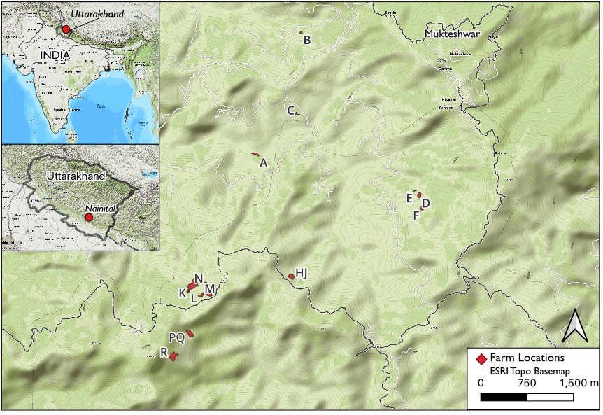
Figure S1. Map of field study area with each dot representing a farm (N = 13).

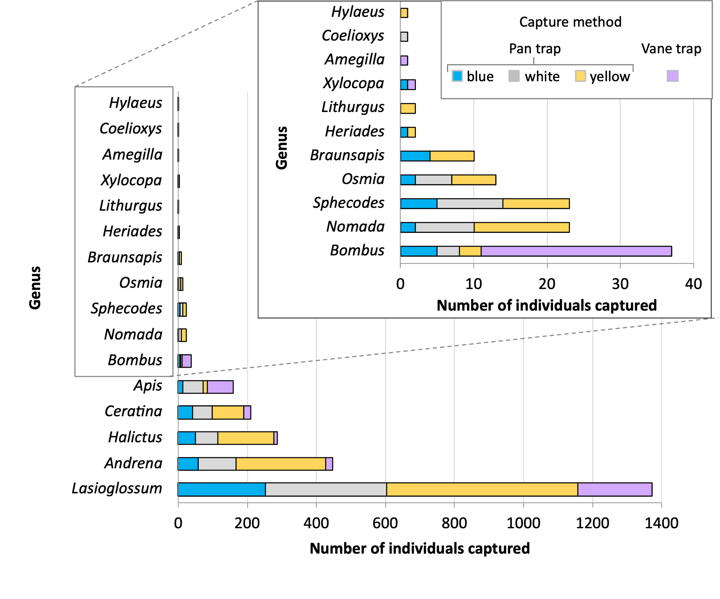

Figure S2. Comparison of the number of bees captured per genus using pan traps of three colours (N = 10 pan traps per colour per sample) and vane traps (N = 1 vane trap per sample). Capture numbers represent cumulative totals from repeated sampling at farms (N = 5 to 6 samples per farm) between 5 February and 27 April 2023, without adjustment for sampling effort.

Figure S3. Relationship between capture method and body size (as measured by intertegular distance, ITD) for bee genera collected from 13 apple orchards between February and April 2023. Mean ITD for each genus was calculated from measurements taken from a random sample of 1 to 6 specimens per species (exception: Bombus haemorrhoidalis = 27 specimens). Relative proportion of captures by trap type is shown by fill color: pan trap ((blue fill) and vane trap (orange fill). Sampling effort differed between methods (30 pan traps vs. 1 vane trap per farm) and total captures were not corrected for sampling effort prior to plotting.

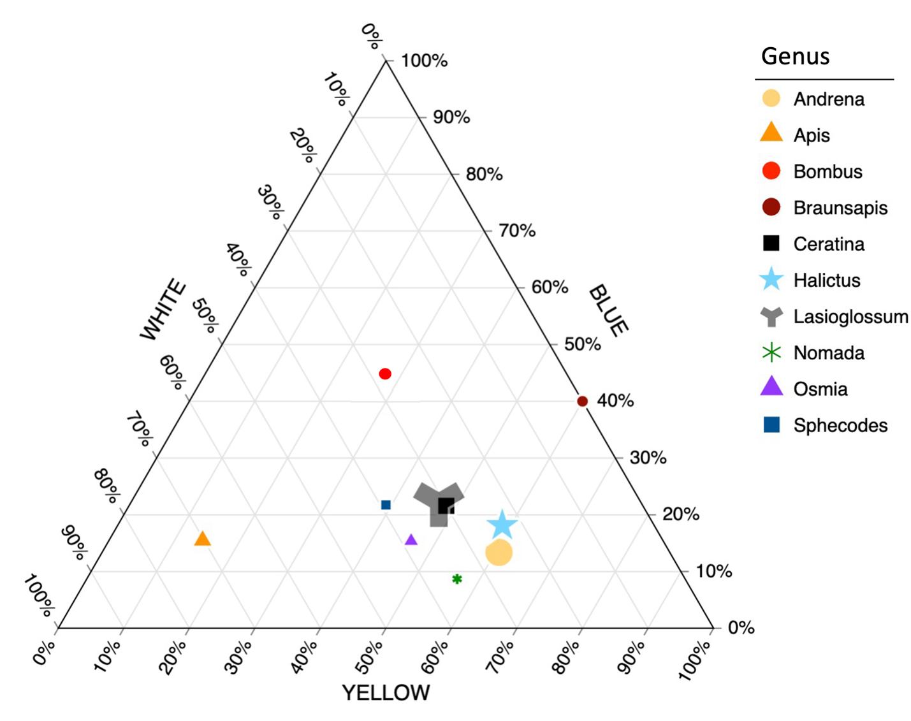

Figure S4. Ternary plot showing the relative percentage of individuals that were collected by blue, yellow and white pan traps. Only genera for which 10 or more individuals were captured by pan traps are included. Abundances were adjusted for sampling effort prior to analysis. Symbol sizes approximate relative abundances of genera across all samples. Plot made using TernaryPlot.com.

