
Appendices to J Poll Ecol 41(8), Zazzera et al.
DOI: 10.26786/1920-7603(2026)860

Supplementary: Figures
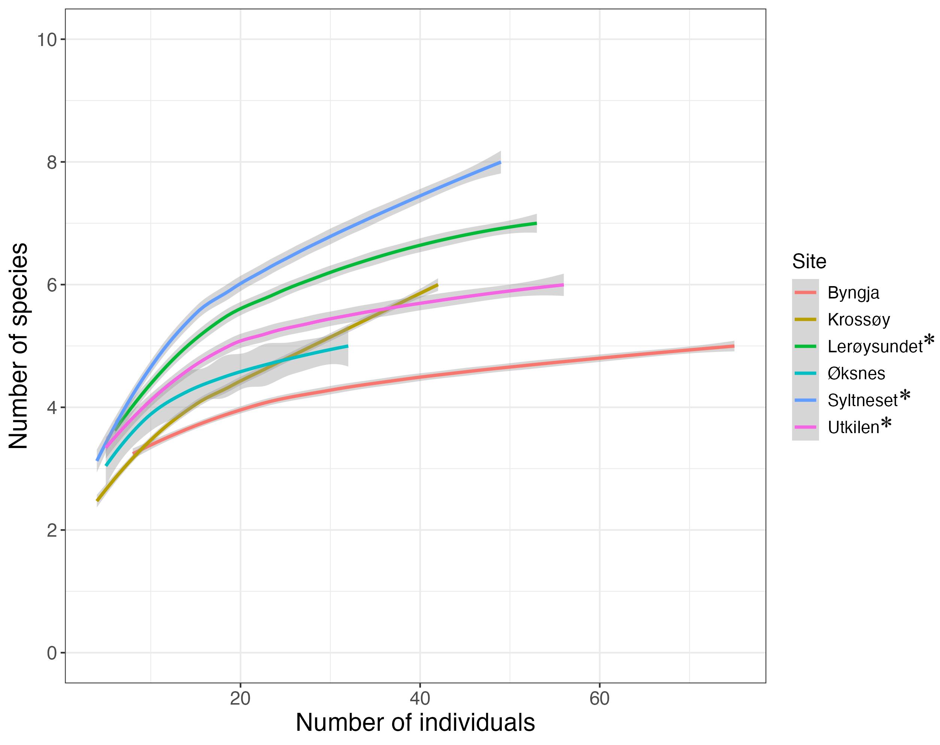 Figure S1: Rarefaction curves for Bombus communities at the six different study sites. Grey area depicts the standard deviation.
*Degenerate heathland sites.

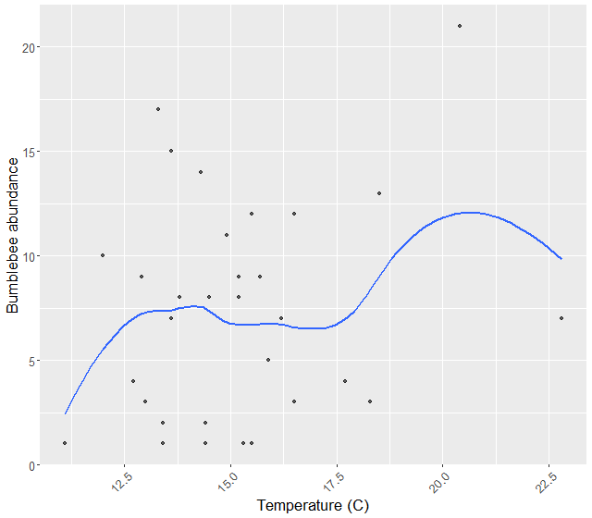Figure S2: Visually exploring relationship between Bombus abundance and temperature.

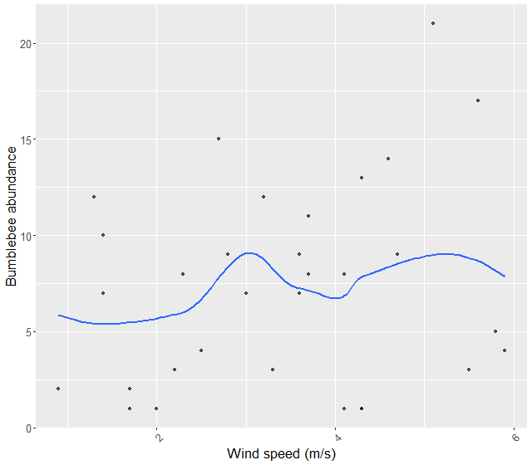Figure S3: Visually exploring relationship between Bombus abundance and wind.
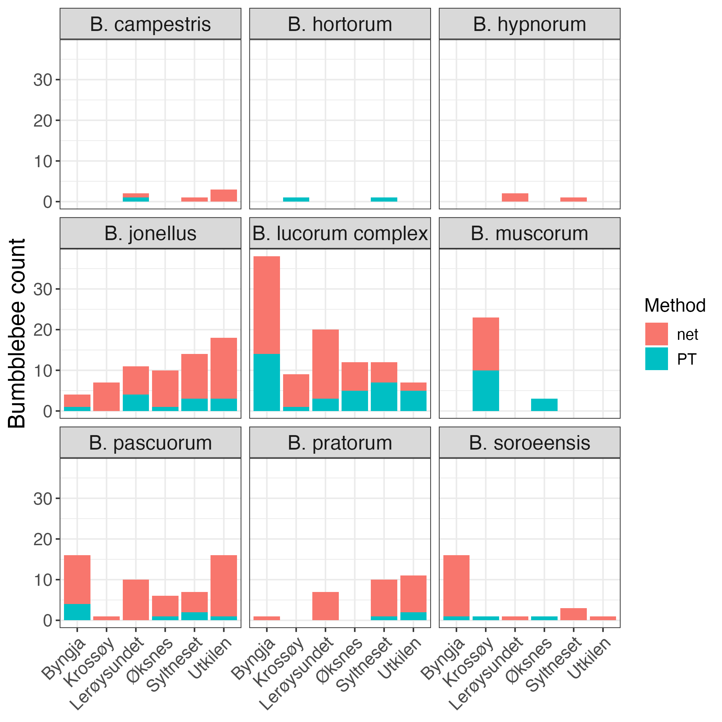Figure S4: Showing the sampling methods for all captured bumblebees at the different sites.

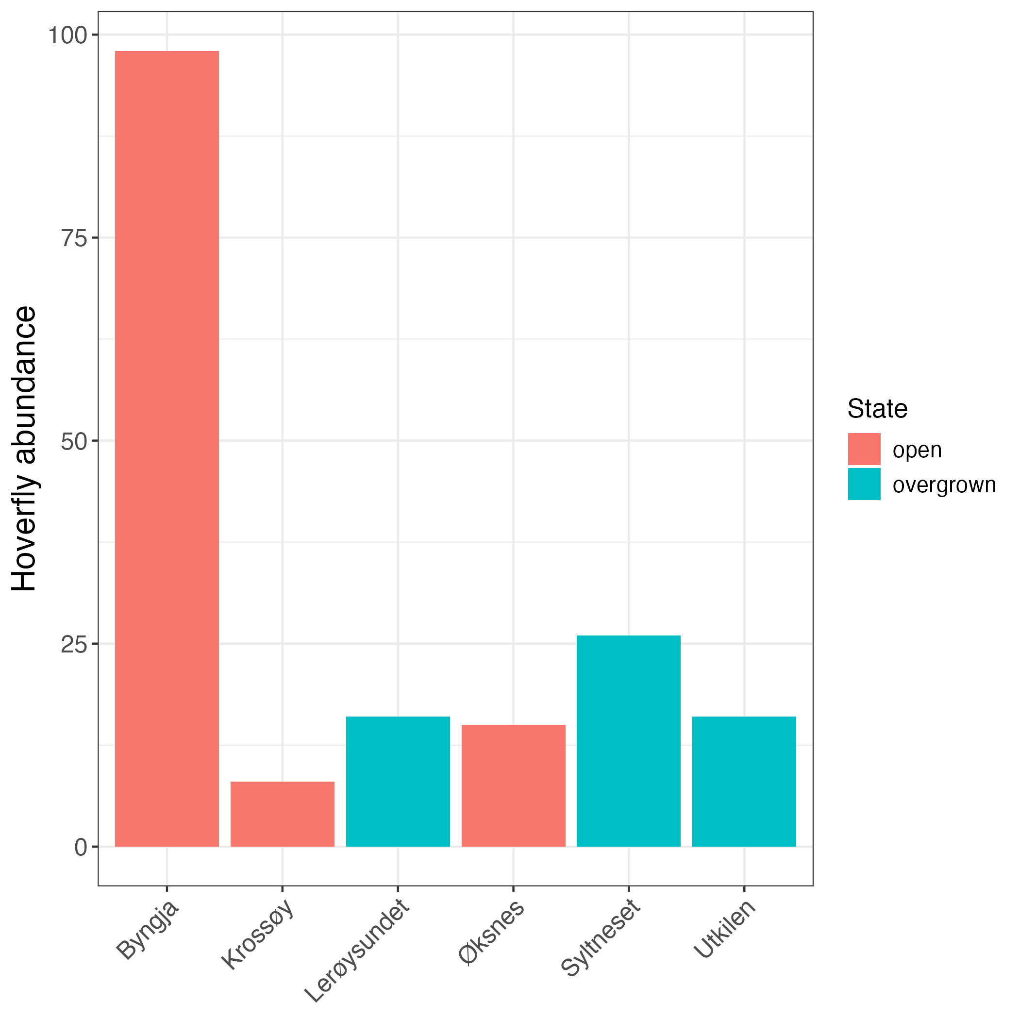
Figure S5: Bar plot showing the abundance of hoverflies (Syrphidae) for the different sites.

Tables
Table S1: Total abundance of all bombus species at all sites in the study.
Site | State | Periode | B. jonellus | B. lucorum complex | B. pascuorum | B. pratorum | B. soroeensis
Byngja | open | first | 2 | 7 | 2 | 1 | 0
Byngja | open | last | 2 | 31 | 14 | 0 | 16
Krossøy | open | first | 1 | 4 | 0 | 0 | 0
Krossøy | open | last | 6 | 5 | 1 | 0 | 1
Lerøysundet | degenerate | first | 11 | 7 | 2 | 7 | 0
Lerøysundet | degenerate | last | 0 | 13 | 8 | 0 | 1
Syltneset | degenerate | first | 14 | 5 | 2 | 10 | 1
Syltneset | degenerate | last | 0 | 7 | 5 | 0 | 2
Utkilen | degenerate | first | 17 | 4 | 3 | 11 | 0
Utkilen | degenerate | last | 1 | 3 | 13 | 0 | 1
Øksnes | degenerate | first | 0 | 2 | 1 | 0 | 0
Øksnes | degenerate | last | 10 | 10 | 5 | 0 | 1

Site | State | Period | B. muscorum | B. hortorum | B. campestris | B. hypnorum
Byngja | open | first | 0 | 0 | 0 | 0
Byngja | open | last | 0 | 0 | 0 | 0
Krossøy | open | first | 1 | 0 | 0 | 0
Krossøy | open | last | 22 | 1 | 0 | 0
Lerøysundet | degenerate | first | 0 | 0 | 1 | 2
Lerøysundet | degenerate | last | 0 | 0 | 1 | 0
Syltneset | degenerate | first | 0 | 0 | 1 | 1
Syltneset | degenerate | last | 0 | 1 | 0 | 0
Utkilen | degenerate | first | 0 | 0 | 2 | 0
Utkilen | degenerate | last | 0 | 0 | 1 | 0
Øksnes | open | first | 1 | 0 | 0 | 0
Øksnes | open | last | 2 | 0 | 0 | 0

Table S2: Total abundance of all solitary bee species at all sites in the study.
Site | State | Period | A. fucata | A. lapponica | A. subopaca | H. hyalinatus | L. albipes | L. calceatum
Byngja | open | first | 3 | 1 | 0 | 0 | 0 | 0
Byngja | open | last | 0 | 0 | 1 | 2 | 0 | 0
Krossøy | open | first | 1 | 0 | 0 | 0 | 4 | 2
Krossøy | open | last | 0 | 0 | 1 | 0 | 1 | 0
Lerøysundet | degenerate | first | 2 | 5 | 0 | 0 | 3 | 2
Lerøysundet | degenerate | last | 0 | 0 | 1 | 0 | 2 | 0
Syltneset | degenerate | first | 2 | 2 | 3 | 0 | 2 | 3
Utkilen | degenerate | first | 2 | 2 | 1 | 0 | 1 | 0
Øksnes | open | first | 0 | 1 | 0 | 0 | 1 | 1
Øksnes | open | last | 0 | 0 | 0 | 0 | 0 | 2

Site | State | Period | L. leucopus | C. succintus | H. brevicornis | A. ruficrus | L. fratellum | L. fulvicorne
Byngja | open | first | 0 | 0 | 0 | 0 | 0 | 0
Byngja | open | last | 0 | 0 | 0 | 0 | 0 | 0
Krossøy | open | first | 1 | 0 | 0 | 0 | 0 | 0
Krossøy | open | last | 0 | 1 | 1 | 0 | 0 | 0
Lerøysundet | degenerate | first | 1 | 0 | 0 | 2 | 1 | 2
Lerøysundet | degenerate | last | 0 | 0 | 0 | 1 | 0 | 0
Syltneset | degenerate | first | 0 | 0 | 0 | 1 | 1 | 0
Utkilen | degenerate | first | 0 | 0 | 0 | 0 | 0 | 2
Øksnes | open | first | 0 | 0 | 0 | 0 | 0 | 3
Øksnes | open | last | 0 | 0 | 0 | 0 | 0 | 0

Site | State | Period | M. circumcincta | N. marshmella | A. semilaevis | A. barbilabris | A. scotica | A. haemorrhoa
Byngja | open | first | 0 | 0 | 0 | 0 | 0 | 0
Byngja | open | last | 0 | 0 | 0 | 0 | 0 | 0
Krossøy | open | first | 0 | 0 | 0 | 0 | 0 | 0
Krossøy | open | last | 0 | 0 | 0 | 0 | 0 | 0
Lerøysundet | degenerate | first | 1 | 1 | 0 | 0 | 0 | 0
Lerøysundet | degenerate | last | 0 | 0 | 2 | 0 | 0 | 0
Syltneset | degenerate | first | 0 | 0 | 0 | 1 | 1 | 0
Utkilen | degenerate | first | 0 | 0 | 0 | 0 | 1 | 1
Øksnes | open | first | 0 | 0 | 0 | 0 | 0 | 0
Øksnes | open | last | 0 | 0 | 0 | 0 | 0 | 0

Table S3: Sites, caste and capturing period for individuals of B. muscorum
Period | Site | Caste | n
first | Krossøy | queen | 1
first | Øksnes | queen | 1
last | Krossøy | drone | 1
last | Krossøy | queen | 6
last | Krossøy | worker | 15
last | Øksnes | queen | 1
last | Øksnes | worker | 1

Table S4: Coefficients for the negative binomial generalized linear model showing the relationship between weather and bumblebee abundance.
 | Estimate | Std. Error | z value | Pr(>|z|)
(Intercept) | 1.06028 | 0.83823 | 1.265 | 0.206
temperature_C | 0.06087 | 0.05423 | 1.122 | 0.262

Table S5: Mean cover (percentage) of various flowering plant species in the open and overgrown heathlands of this study and mean cover of tree canopy surrounding the different sites, in a 1 km radius from the middle of the site.
Site | State | Vaccinium uliginosum (%) | Erica tetralix (%) | Calluna vulgaris (%) | Vaccinium vitis-idaeaa (%)
Byngja | Open | 4 | 13 | 33 | 2
Krossøy | Open | 2 | 11 | 28 | 1
Øksnes | Open | 0 | 3 | 35 | 0
Lerøysundet | degenerate | 32 | 3 | 19 | 1
Syltneset | degenerate | 34 | 2 | 15 | 6
Utkilen | degenerate | 8 | 8 | 20 | 7

Site | State | Arctostaphylos uva-ursi (%) | Cornus suecica (%) | Potentilla erecta (%) | Lotus corniculatus (%)
Byngja | Open | 4 | 4 | 2 | 0
Krossøy | Open | 0 | 0 | 4 | 9
Øksnes | Open | 8 | 0 | 1 | 0
Lerøysundet | degenerate | 1 | 4 | 2 | 0
Syltneset | degenerate | 0 | 1 | 2 | 0
Utkilen | degenerate | 0 | 1 | 2 | 0
Site | State | Erica cinerea (%)
Byngja | Open | 0
Krossøy | Open | 1
Øksnes | Open | 0
Lerøysundet | degenerate | 0
Syltneset | degenerate | 0
Utkilen | degenerate | 0

Table S6: Importance of components in Principal Component Analysis (PCA)
 | PC1 | PC2 | PC3 | PC4 | PC5
Eigenvalue | 3.5811 | 1.5591 | 0.33926 | 0.2234 | 0.06962
Proportion  Explained | 0.6204 | 0.2701 | 0.05877 | 0.0387 | 0.01206
Cumulative Proportion | 0.6204 | 0.8905 | 0.94924 | 0.9879 | 1.00000

Table S7 a): Importance of components in Redundancy Analysis (RDA)
 | RDA1 | RDA2 | RDA3
Eigenvalue | 1.6381 | 0.7216 | 0.06765
Proportion Explained | 0.6749 | 0.2973 | 0.02787
Cumulative Proportion | 0.6749 | 0.9721 | 1.00000

b): Significance of the redundancy analysis model (RDA)
 | Df | Varince | F | Pr(>F)
Model | 3 | 2.4273 | 2.31 | 0.022
Residual | 8 | 2.8021

c): Significance of variables in redundancy analysis model (RDA)
 | Df | Variance | F | Pr(>F)
state | 1 | 0.78559 | 2.2429 | 0.082
period | 1 | 1.34027 | 3.8265 | 0.007
Calluna vulgaris (%) | 1 | 0.30144 | 0.8606 | 0.517
Residual | 8 | 2.80210

