
Appendices to J Poll Ecol 40(4), Wiegel & Lunau
DOI: 10.26786/1920-7603(2026)870

FIGURES

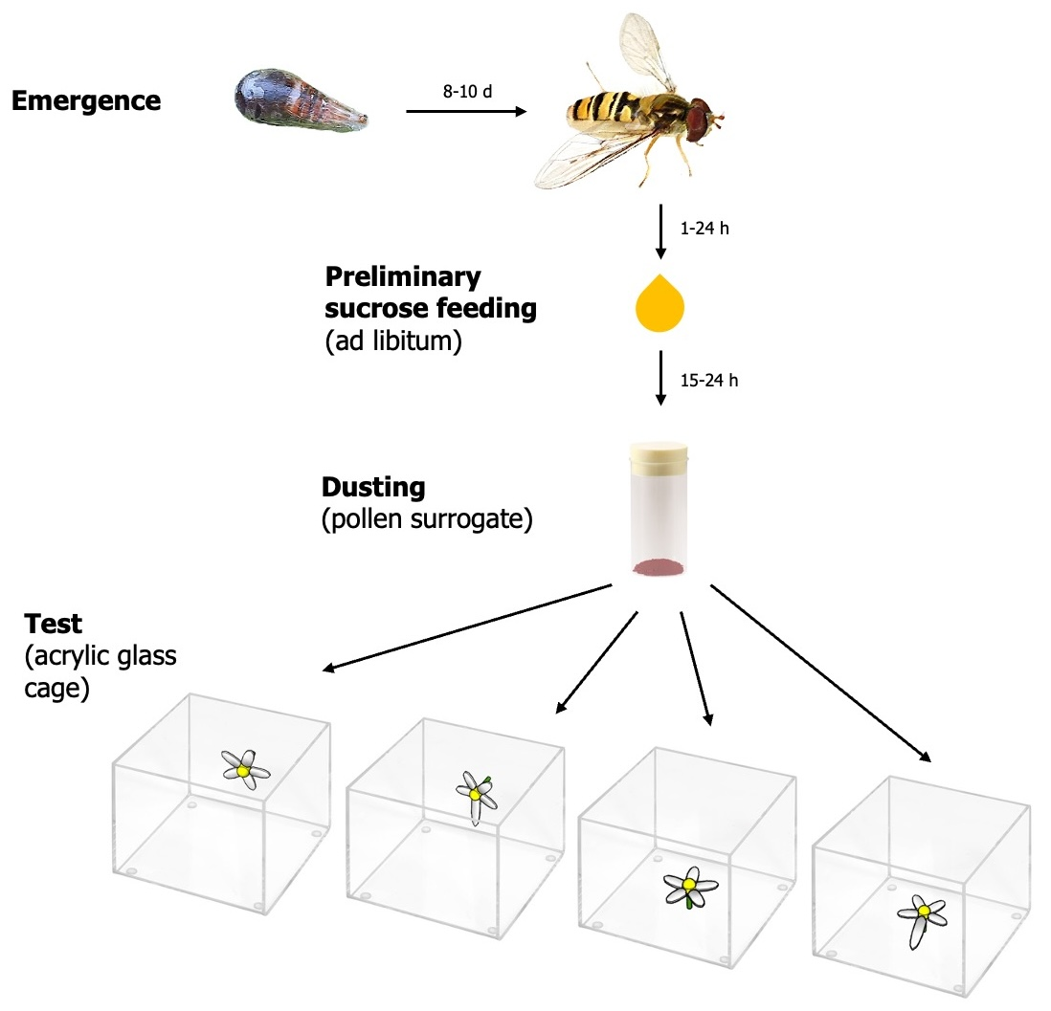
Figure S1. Experimental design of the pollen transfer quantification test.
Pigment deposition on flowers of Saxifraga fortunei by Episyrphus balteatus hoverflies, that were previously fed on sucrose and dusted with a pollen surrogate was quantified in response to flower symmetry and orientation.

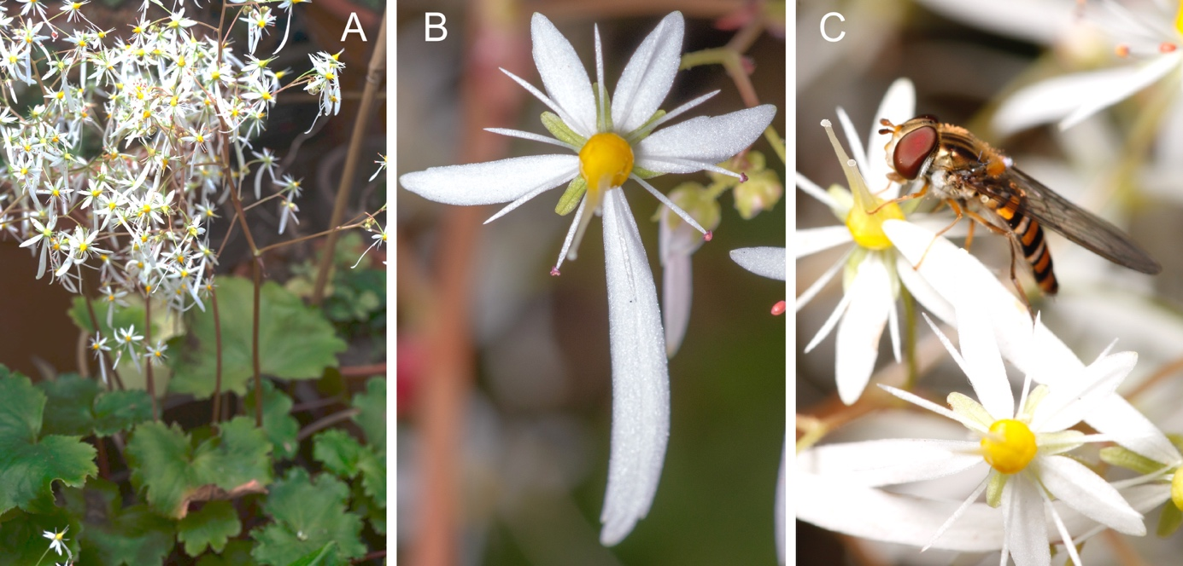
Figure S2. Single flower with Episyrphus balteatus and inflorescences of Saxifraga fortunei.
(A) Inflorescences with predominantly vertical oriented flowers. (B) Single bilaterally symmetrical flower of S. fortunei with two differently elongated lower petals in combination with extended interpetal angles on both sides. (C) Episyrphus balteatus on a flower of S. fortunei.

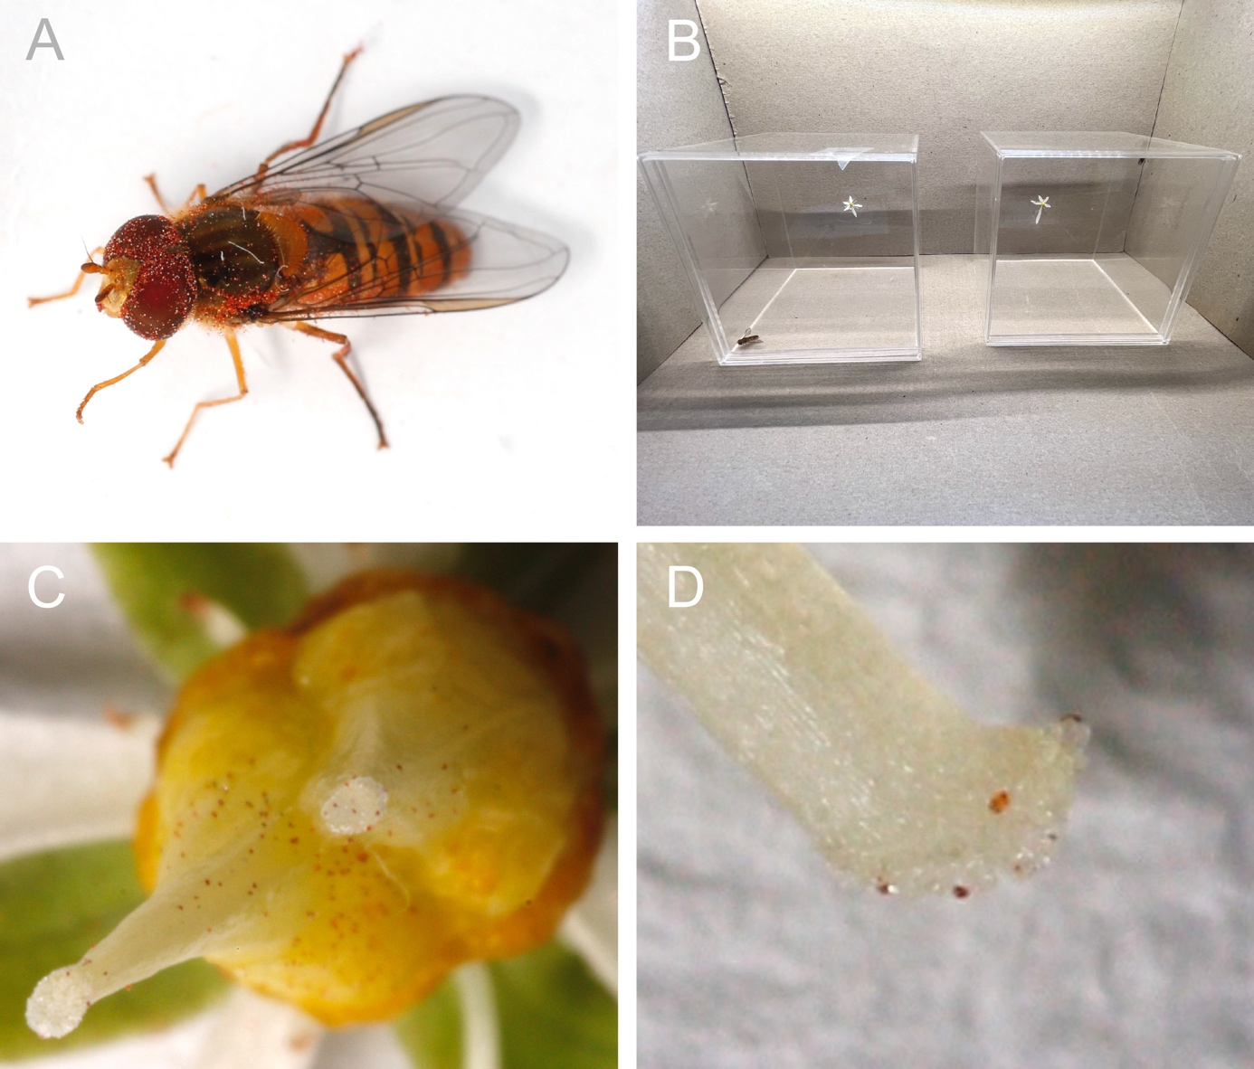
Figure S3. Experimental approach to quantify pollen placement efficiency with pigments as pollen analogues and macro-stigmagraphy.
(A) E. balteatus covered with red burnt ferrous oxide pigments as pollen analogues. (B) Two acrylic glass cages as experimental arenas in a colour-neutral grey box with a vertically displayed flower of S. fortunei each. The left box contains a bilaterally symmetrical flower that was manipulated to a radially symmetrical flower by the reduction of the elongated lower petal, the right box contains a naturally bilaterally symmetrical flower. (C) Macro-photography of a flower of S. fortunei after a flower visitation. Pigment particles on the stigmatic surface are clearly detectable, as well as the distribution of pollen surrogate on the whole carpels. (D) Close-up sideview with a detailed view on the planar stigmatic structure with a distinct delimitation of the style and the receptive surface.

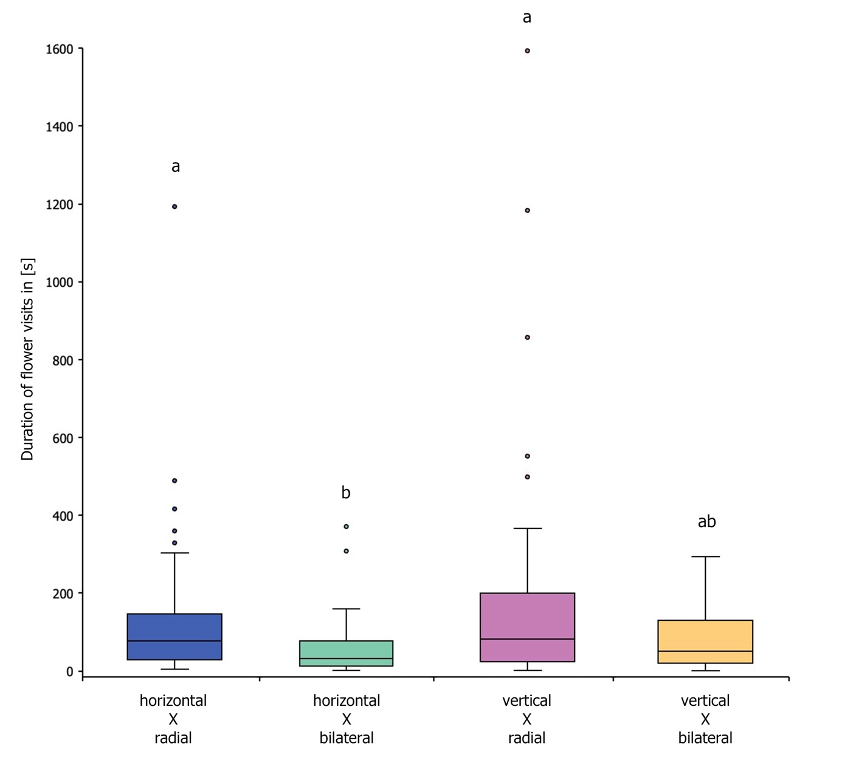
Figure S4. Duration of flower visits to Saxifraga stellaris flowers in relation to shape-angle combinations.
The y-axis represents the duration of flower visits (in seconds), while the y-axis indicates the shape-angle combinations. Floral symmetry significantly impacted the duration of flower visits. Shared letters are not significantly different according to Dunn-Bonferroni post-hoc test at P < 0.05.

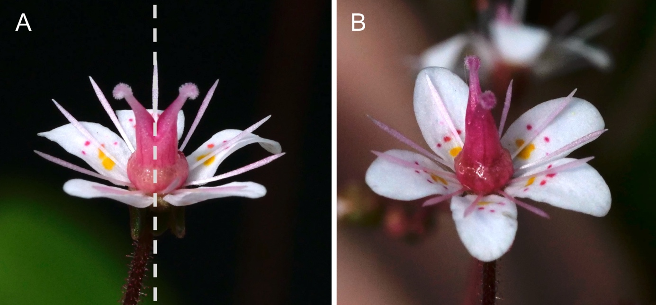
Figure S5. Optical contortion of a radially symmetrical flower of S. umbrosa.
(A) Approaching a radially symmetrical flower from the side leads to an optical contortion resulting in a slight bilaterally symmetrical image; the axis of bilateral symmetry is shown by a dashed white line. (B) Same flower viewed from a higher inclination.

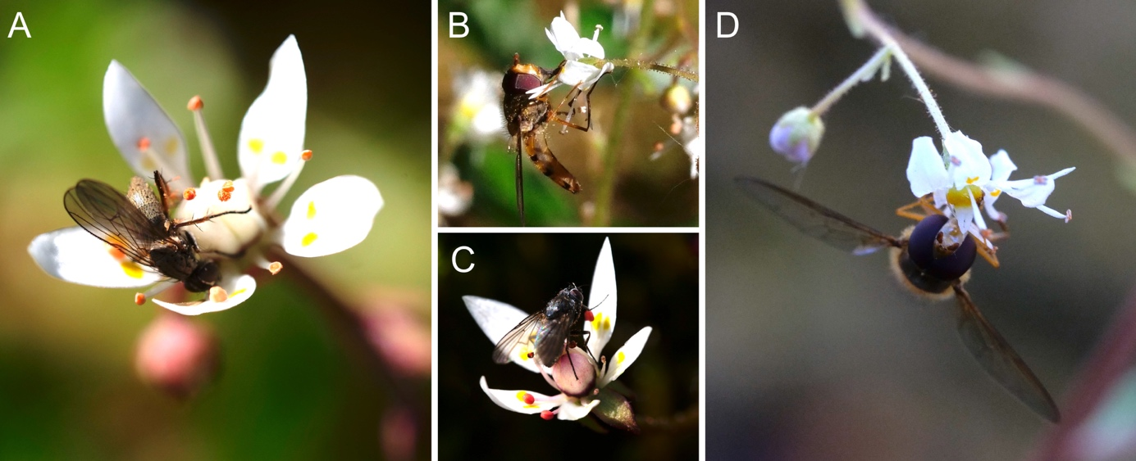
Figure S6. Behavioural variations of pollinators through mechanical constraints.
The stability of flowers varies with respect to flower orientation. In vertically oriented flowers the insects have to apply more force to hold on to the bending petals under their weight. Both orientations can lead to contacts with reproductive structures. (A) Non-syrphid fly on a horizontal flower of S. stellaris with contact to anthers. (B) Syrphid fly on a vertical flower of S. cuneifolia with contact to anthers and stigmas. The flower is notably compressed. (C) Non-syrphid fly on a horizontal flower of S. stellaris with contact to stigmas. (D) Syrphid fly on a vertical flower of S. cuneifolia with contact to anthers. The flower is notably compressed.

Appendix I. Fine-scale analysis of landing angles
Following Jirgal and Ohashi (2023), fine-scale landing angle data, transferred from degrees to radians, were used to calculate the circular variance, also known as the mean resultant length (MRL), for each observation. The circular variance is calculated by dividing the observed length of the resultant vector (a measure of the direction of the angles) by the maximum possible length of the resultant vector for the same size of sample. For the calculation of MRL, the rho.circular function from the R package ‘circular’ was used (Pewsey et al. 2013). To analyse the landing angles, MRL values were converted into circular standard deviation (circular SD) using the following formula:
$$circular SD=\frac{180}{π}⋅\sqrt{-2⋅\log{(MRL)}}$$
where π is the circular constant. The circular SD represents the dispersion of the dataset in relation to the mean – here mean landing angle, expressed in degrees (Pewsey et al. 2013). Given the bilaterally symmetrical shape of Saxifraga flowers, landing angles might not follow a unimodal distribution. Therefore, Hartigans’ dip test for unimodality was applied. The circular standard deviation was calculated using angles from 0°–180°, instead of 0°–360°, by subtracting any angles larger than 180° from 360° prior to converting the angles from degrees to radians. Levene’s test for homogeneity of variance and Shapiro-Wilk test for normality were applied to verify statistical test assumptions. A visual assessment of the QQ-plot of the residuals and Shapiro-Wilk test indicated that the dataset followed a non-normal distribution. A two-way (factorial) test design was used to determine whether and how floral symmetry and orientation affected the variance of flower visitor landing directionality in S. stellaris by performing a Scheirer-Ray-Hare test as a non-parametric alternative to a two-way (factorial) analysis of variance (ANOVA) (Scheirer et al. 1976; Sokal & Rohlf 2010). The circular SD was used as the response variable. Floral symmetry and orientation were considered as fixed effects in combination with an interaction term between symmetry and orientation. The observed distributions of fine-scale landing angles were visualised in circular boxplots (Abuzaid et al. 2012; Buttarazzi et al. 2018).

In fine-scale analysis of flower visitors’ landing angles neither flower symmetry, nor flower orientation impacted the variance of landing angles significantly in any of the four shape-angle combinations in S. stellaris (between orientations: H = 3.083, P = 0.079, Scheirer-Ray-Hare test; between symmetries: H = 1.275, P = 0.259, Scheirer-Ray-Hare test; interaction of symmetry*orientation: H = 0.071, P = 0.789, Scheirer-Ray-Hare test), when using angles ranging from 0°–360° (Fig. S9). The analysis of the variance of landing angles on a 0°–180° scale didn’t reveal any significant differences between the shape-angle combinations in flowers of S. stellaris either (between orientations: H = 0.322, P = 0.571, Scheirer-Ray-Hare test; between symmetries: H = 0.046, P = 0.829, Scheirer-Ray-Hare test; interaction of symmetry*orientation: H = 2.275, P = 0.131, Scheirer-Ray-Hare test) (Fig. S10). The bimodal distribution of pollinator landing angles with two peaks, one on each side of the flower’s principal vertical axis, led to a larger variance of landing angles as when they are viewed as mirror images of the same angle. Similar results could be found for S. cuneifolia as for S. stellaris, when analysing angles ranging from 0°–360° (between orientations: W = 308.5, P = 0.758, Mann-Whitney-U test) (Fig. S7). Flower orientation had no significant impact on the circular variance of landing angles. The analysis of the variance of landing angles on a 0°–180° scale revealed significant differences between flower orientations of S. cuneifolia (between orientations: W = 487.5, P = 0.003, Mann-Whitney-U test) (Fig. S8).

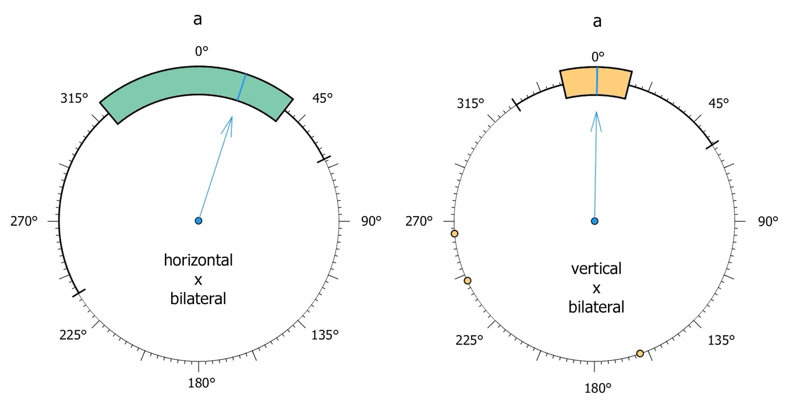
Figure S7. Fine-scale data of flower visitors landing angles in S. cuneifolia using angles ranging from 0°–360°.
Circular variance of flower visitors landing angles in flowers with different flower orientations as shown by coloured boxplots. Arrows indicating the median. Shared letters are not significantly different at P < 0.05.

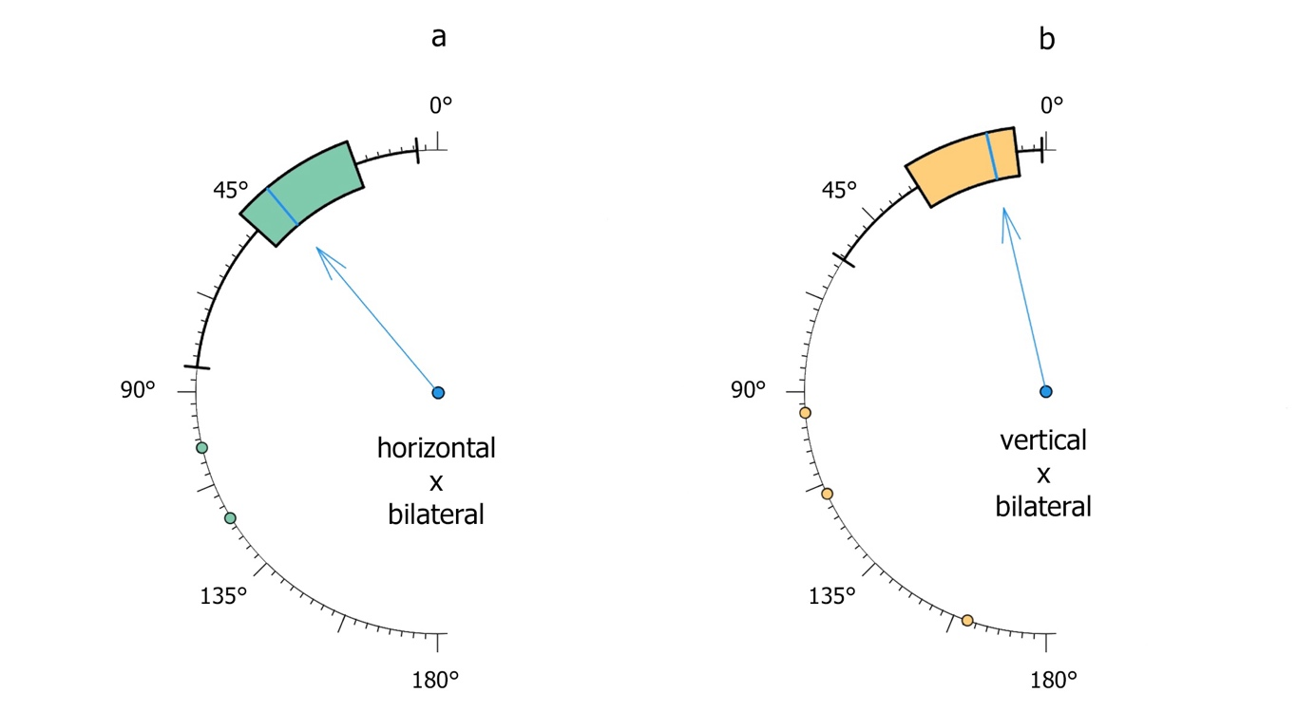
Figure S8. Fine-scale data of flower visitors landing angles in S. cuneifolia using angles ranging from 0°–180° (landing angles >180° were translated to corresponding landing angles <180°).
Circular variance of flower visitors landing angles in flowers with different flower orientations as shown by coloured boxplots. Arrows indicating the median. Shared letters are not significantly different at P < 0.05. Flower orientation significantly impacted the directionality of flower visitors.

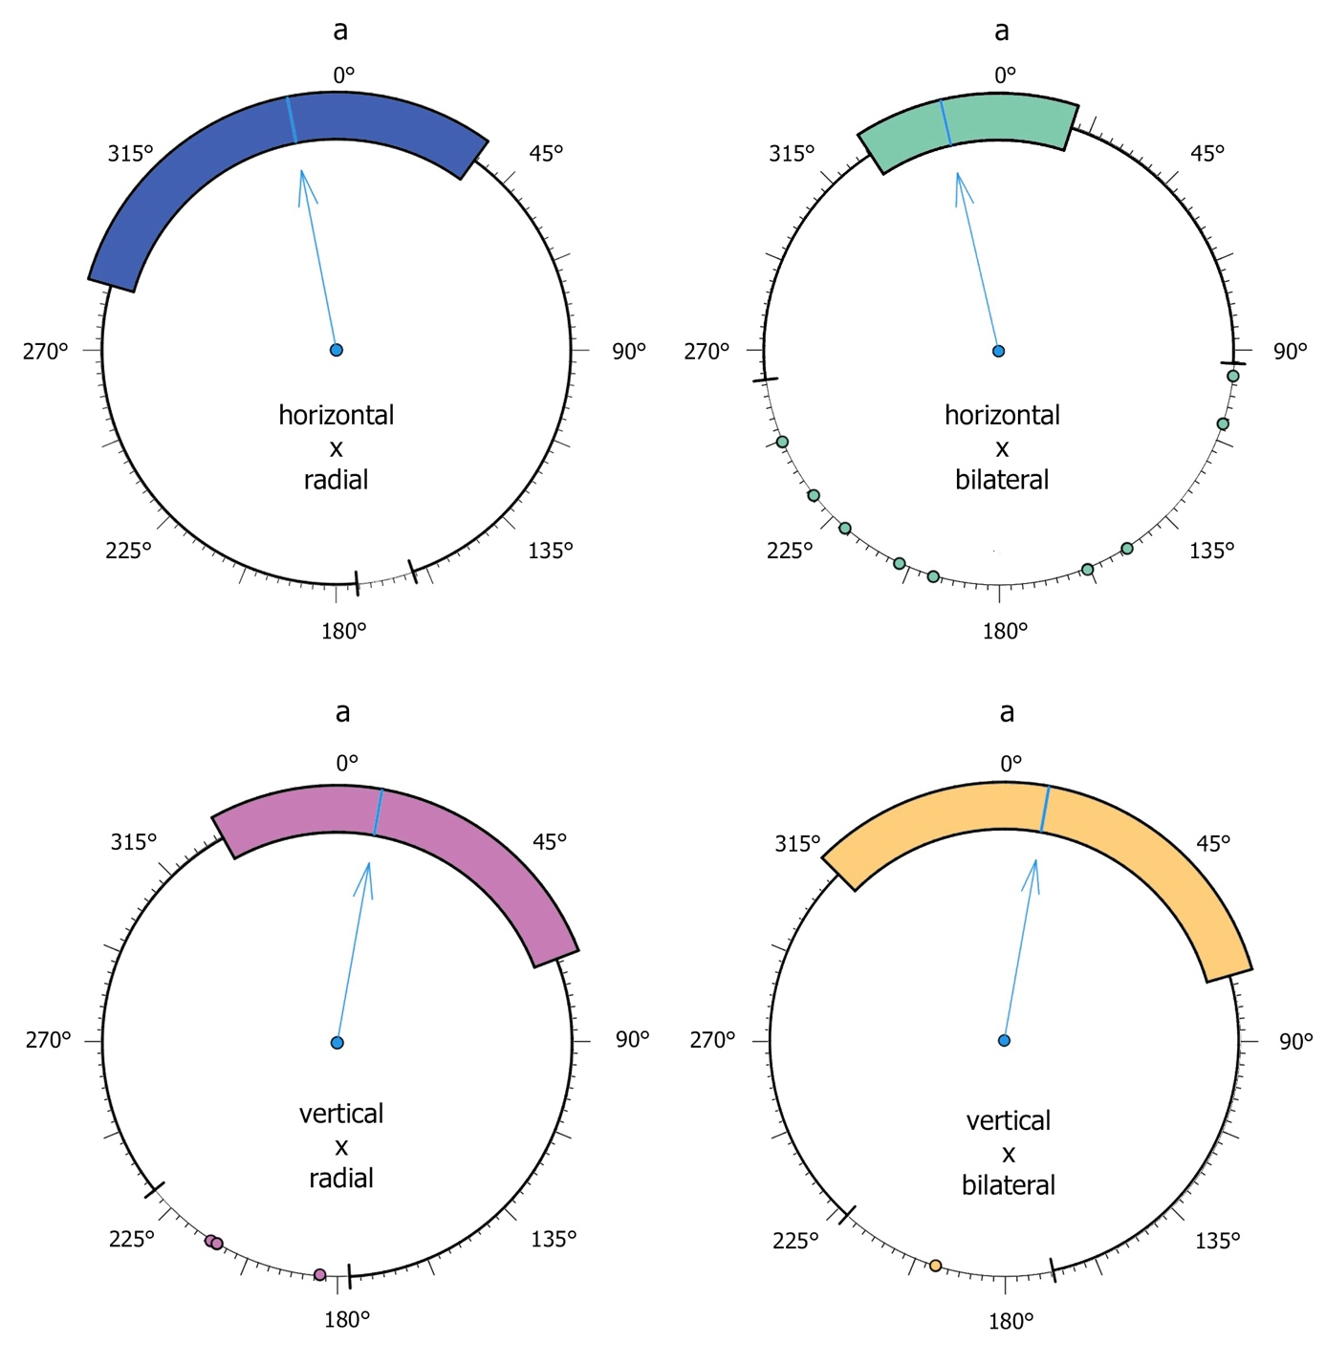
Figure S9. Fine-scale data of flower visitors landing angles in S. stellaris using angles ranging from 0°–360°.
Circular variance of flower visitors landing angles in flowers with different flower orientations as shown by coloured boxplots. Arrows indicating the median. Shared letters are not significantly different at P < 0.05.

Figure S10. Fine-scale data of flower visitors landing angles in S. stellaris using angles ranging from 0°–180° (landing angles >180° were translated to corresponding landing angles <180°).
Circular variance of flower visitors landing angles in flowers with different flower orientations as shown by coloured boxplots. Arrows indicating the median. Shared letters are not significantly different at P < 0.05.

Abuzaid AH, Mohamed IB, Hussin AG (2012) Boxplot for circular variables. Computational Statistics 27:381–392. https://doi.org/10.1007/s00180-011-0261-5
Buttarazzi D, Pandolfo G, Porzio GC (2018) A Boxplot for circular data. Biometrics 74:1492–1501. https://doi.org/10.1111/biom.12889
Jirgal N, Ohashi K (2023) Effects of floral symmetry and orientation on the consistency of pollinator entry angle. The Science of Nature 110:19. https://doi.org/10.1007/s00114-023-01845-w
Pewsey A, Neuhäuser M, Ruxton GD (2013) Circular statistics in R, 1. ed. Oxford Univ. Press, Oxford.
Scheirer CJ, Ray WS, Hare N (1976) The analysis of ranked data derived from completely randomized factorial designs. Biometrics 32:429–434. https://doi.org/10.2307/2529511
Sokal RR, Rohlf FJ (2010) Biometry: the principles and practice of statistics in biological research, 3. ed., 11. print. Freeman, New York, NY.

Appendix II. Statistical test results including post-hoc tests.
In the following all statistical test results and post-hoc test results are provided. Statistically significant results at P < 0.05 are highlighted by bold P-values.
h = horizontal
v = vertical
p = radially symmetrical (polysymmetrical)
m =bilaterally symmetrical (monosymmetrical)

Flower visitors’ approach behaviour
Details of statistical analysis of landing angles:

Response variable | Variables | Test | Sample size |  | df | χ²/H/W | P-value
Saxifraga cuneifolia
distribution categorial angles | orientation h–v | Chi-Square | 52 | 1 |  | 4.649 | 0.199
angle categories | h x m | Chi-Square | 21 | 3 |  | 21.095 | 1.006*10⁻⁴
angle categories | v x m | Chi-Square | 31 | 3 |  | 57.645 | 1.871*10⁻¹²
angles 360° scale | orientation h–v | Mann-Whitney-U | 52 | 1 |  | 308.5 | 0.758
angles 180° scale | orientation h–v | Mann-Whitney-U | 52 | 1 |  | 487.5 | 0.003
Saxifraga stellaris
distribution categorial angles | orientation h–v | Chi-Square | 218 | 1 |  | 2.231 | 0.526
distribution categorial angles | symmetry p–m | Chi-Square | 218 | 1 |  | 1.751 | 0.626
angle categories | h x p | Chi-Square | 77 | 3 |  | 14.481 | 0.002
angle categories | h x m | Chi-Square | 49 | 3 |  | 27.49 | 4.647*10⁻⁶
angle categories | v x p | Chi-Square | 59 | 3 |  | 18.898 | 2.87*10⁻⁴
angle categories | v x m | Chi-Square | 33 | 3 |  | 5.667 | 0.129
angles 360° scale | orientation h–v | Scheirer-Ray-Hare | 218 | 1 |  | 3.083 | 0.079
angles 360° scale | symmetry p–m | Scheirer-Ray-Hare | 218 | 1 |  | 1.275 | 0.259
angles 360° scale | symmetry*orientation | Scheirer-Ray-Hare | 218 | 1 |  | 0.071 | 0.789
angles 180° scale | orientation h–v | Scheirer-Ray-Hare | 218 | 1 |  | 0.322 | 0.571
angles 180° scale | symmetry p–m | Scheirer-Ray-Hare | 218 | 1 |  | 0.046 | 0.829
angles 180° scale ° | symmetry*orientation | Scheirer-Ray-Hare | 218 | 1 |  | 2.275 | 0.131
Saxifraga cuneifolia – Saxifraga stellaris
Landing angle | species | Chi-Square | 52  218 | 1 |  | 17.607 | 0.001

Post-hoc tests of the analysis of categorial landing angles:

P-values of the comparison of the four angle categories in h x m (S. cuneifolia)
 | top | right | bottom
right | 0.018
bottom | < 0.001 | 0.134
left | 0.008 | 1.000 | 0.248
Post-hoc test: pairwise Chi-Square test

P-values of the comparison of the four angle categories in v x m (S. cuneifolia)
 | top | right | bottom
right | < 0.001
bottom | < 0.001 | 1.000
left | < 0.001 | 1.000 | 1.000
Post-hoc test: pairwise Chi-Square test

Post-hoc tests of the analysis of categorial landing angles:

P-values of the comparison of the four angle categories in h x p (S. stellaris)
 | top | right | bottom
right | 0.008
bottom | < 0.001 | 0.414
left | 0.131 | 0.237 | 0.048
Post-hoc test: pairwise Chi-Square test

p-values of the comparison of the four angle categories in h x m (S. stellaris)
 | top | right | bottom
right | < 0.001
bottom | < 0.001 | 0.405
left | < 0.001 | 1.000 | 0.405
Post-hoc test: pairwise Chi-Square test

P-values of the comparison of the four angle categories in v x p (S. stellaris)
 | top | right | bottom
right | 0.008
bottom | < 0.001 | 0.371
left | 0.002 | 0.669 | 0.637
Post-hoc test: pairwise Chi-Square test

Details of statistical analysis of landing position:

Response variable | Variables | Test | Sample size | df | χ²/F/W | P-value
Saxifraga cuneifolia
distribution categorial positions | orientation h–v | Fisher’s Exact | 52 | 1 |  | 0.043
position categories | h x m | Fisher’s Exact | 21 | 4 |  | 0.202
position categories | v x m | Fisher’s Exact | 31 | 4 |  | 0.465
Saxifraga stellaris
distribution categorial positions | orientation h–v | Chi-Square | 218 | 1 | 1.344 | 0.854
distribution categorial positions | symmetry p–m | Chi-Square | 218 | 1 | 8.64 | 0.071
position categories | h x p | Chi-Square | 77 | 4 | 16.312 | 0.003
position categories | h x m | Chi-Square | 49 | 4 | 23.959 | 8.139*10⁻⁵
position categories | v x p | Chi-Square | 59 | 4 | 9.22 | 0.055
position categories | v x m | Chi-Square | 33 | 4 | 3.515 | 0.476
distribution categorial positions | symmetry*orientation | Chi-Square | 218 | 3 | 25.449 | 0.013

Post-hoc tests of the analysis of categorial landing positions:

P-values of the comparison of the five categories of landing positions in h x p (S. stellaris)
 | top | right | bottom | left
right | < 0.001
bottom | < 0.001 | 0.307
left | 0.669 | 0.157 | 0.016
centre | 0.637 | 0.023 | 0.001 | 0.037
Post-hoc test: pairwise Chi-Square test

P-values of the comparison of the five categories of landing positions in h x m (S. stellaris)
 | top | right | bottom | left
right | 1.000
bottom | < 0.001 | < 0.001
left | 0.003 | < 0.001 | 0.590
centre | 0.002 | < 0.001 | 0.724 | 0.853
Post-hoc test: pairwise Chi-Square test

P-values of the comparison of landing positions between the four shape-angle combinations (S. stellaris)
 | h x p | h x m | v x p
h x m | 2.058*10⁻⁴
v x p | 0.086 | 0.205
v x m | 0.397 | 0.02 | 0.622
Post-hoc test: pairwise Chi-Square test

Details of statistical analysis of the duration of flower visits:

Response variable | Variables | Test | Sample size | df | χ²/F/W | P-value
Saxifraga cuneifolia
duration | orientation h–v | Mann-Whitney-U | 52 | 1 | 340.0 | 0.794
Saxifraga stellaris
duration | orientation h–v | Mann-Whitney-U | 218 | 1 | 5322 | 0.303
duration | symmetry p–m | Mann-Whitney-U | 218 | 1 | 4096 | 0.001
duration | symmetry*orientation | Kruskal-Wallis | 218 | 3 | 11.68 | 0.008

Post-hoc tests of the analysis of the duration of flower visit:

P-values of the comparison of the duration of flower visits between the four shape-angle combinations
 | h x p | h x m | v x p
h x m | 0.024
v x p | 1.000 | 0.014
v x m | 1.000 | 1.000 | 0.875
Post-hoc test: Dunn-Bonferroni test

Pollen placement efficiency
Details of statistical analysis of pollen surrogate deposition:

Response variable | Variables | Test | Sample size | df | χ²/F/W | P-values
pigment count | orientation h–v | ANOVA | 120 | 1 | 17.266 | 6.24*10⁻⁵
pigment count | symmetry p–m | ANOVA | 120 | 1 | 3.643 | 0.059
pigment count | symmetry*orientation | ANOVA | 120 | 1 | 0.811 | 0.369
duration | orientation h–v | ANOVA | 120 | 1 | 0.000 | 0.992
duration | symmetry p–m | ANOVA | 120 | 1 | 0.174 | 0.677
duration | symmetry*orientation | ANOVA | 120 | 1 | 0.006 | 0.938
pigment per time  (time until visit) | symmetry*orientation | linear regression | 120 |  | 3.272 | 0.073
pigment per time  (duration of visit) | symmetry*orientation | linear regression | 120 |  | 0.065 | 0.799

Post-hoc tests of the analysis of pollen surrogate deposition:

P-values of the comparison of pollen surrogate deposition between the four shape-angle combinations
 | h x p | h x m | v x p
h x m | 0.892
v x p | 0.003 | < 0.001
v x m | 0.389 | 0.104 | 0.199
Post-hoc test: Tukey HSD test

Appendix III. Raw data.

Raw data of flower visitors’ approach behaviour
Data of S. cuneifolia horizontal x monosymmetrical:
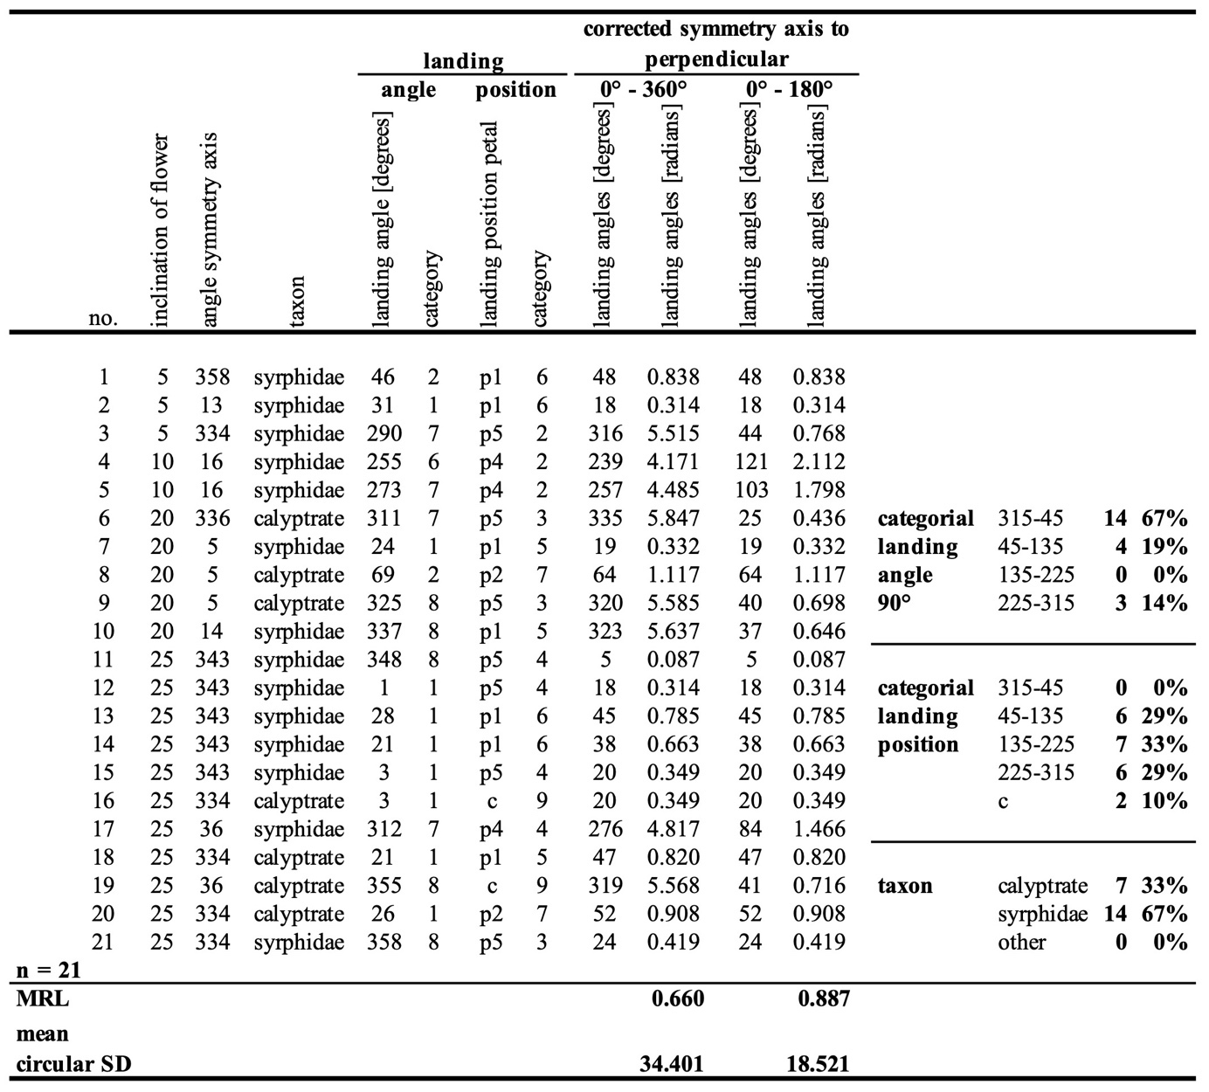

Data of S. cuneifolia vertical x monosymmetrical:
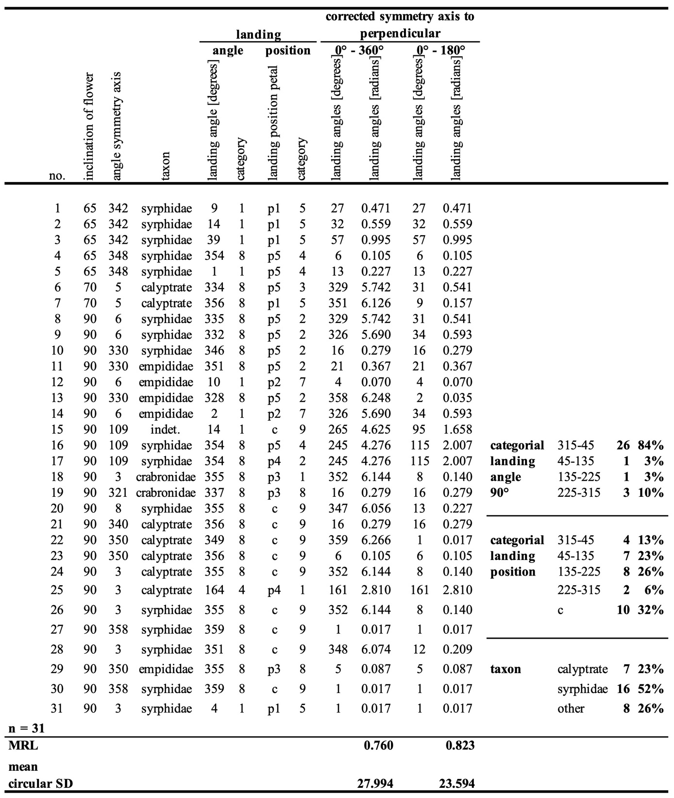

Data of S. stellaris horizontal x polysymmetrical
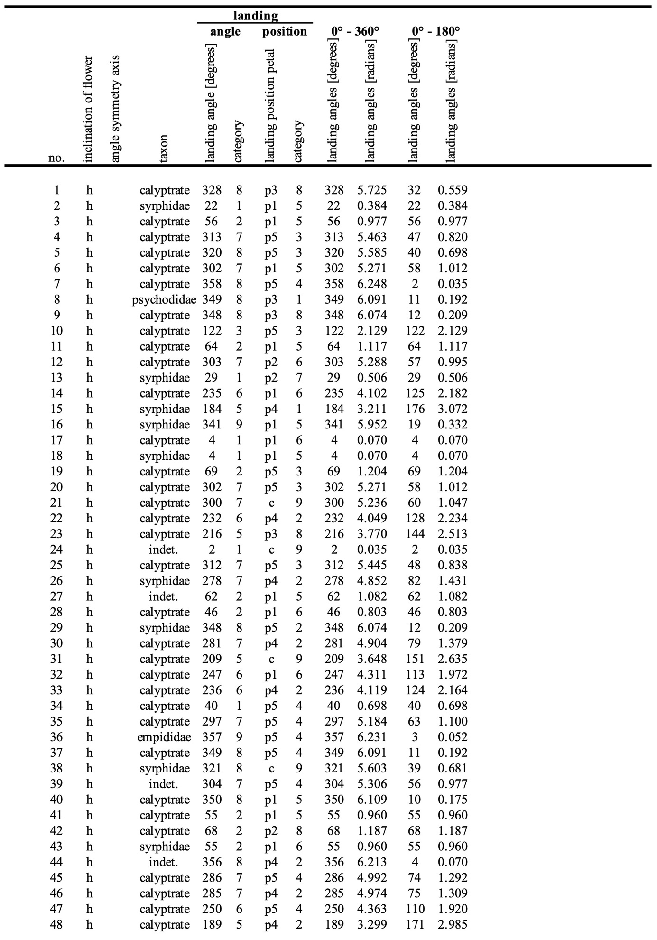

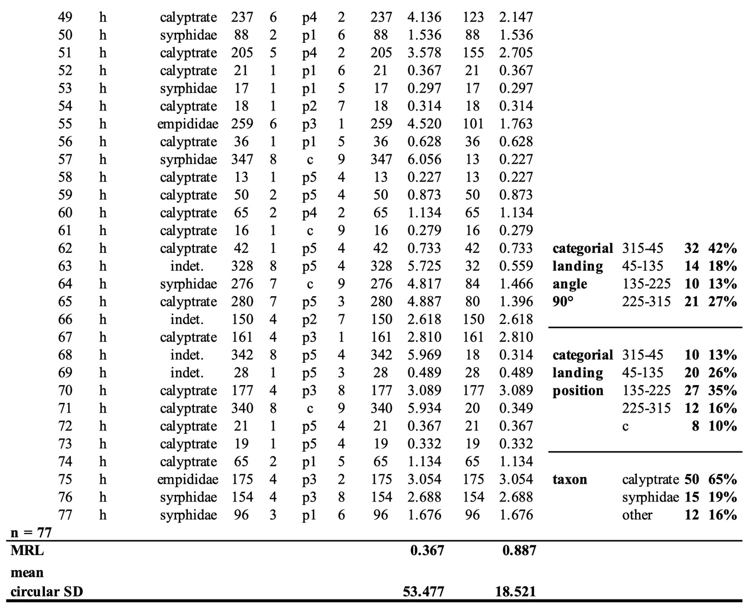

Data of S. stellaris horizontal x monosymmetrical:
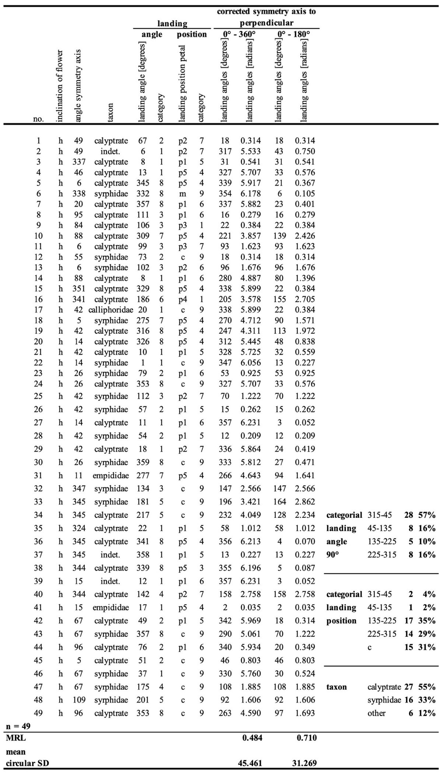

Data of S. stellaris vertical x polysymmetrical:
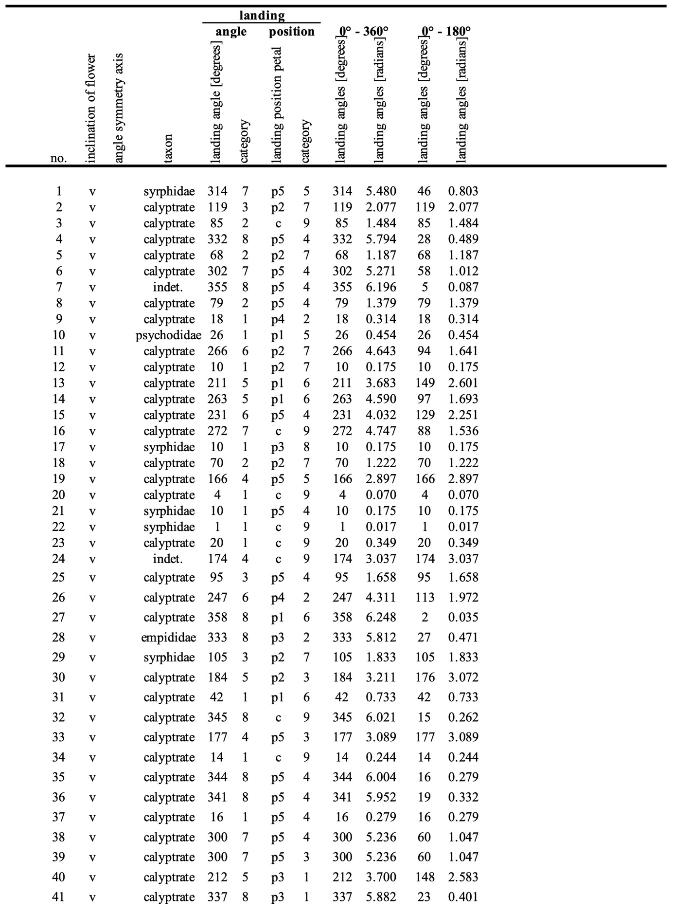

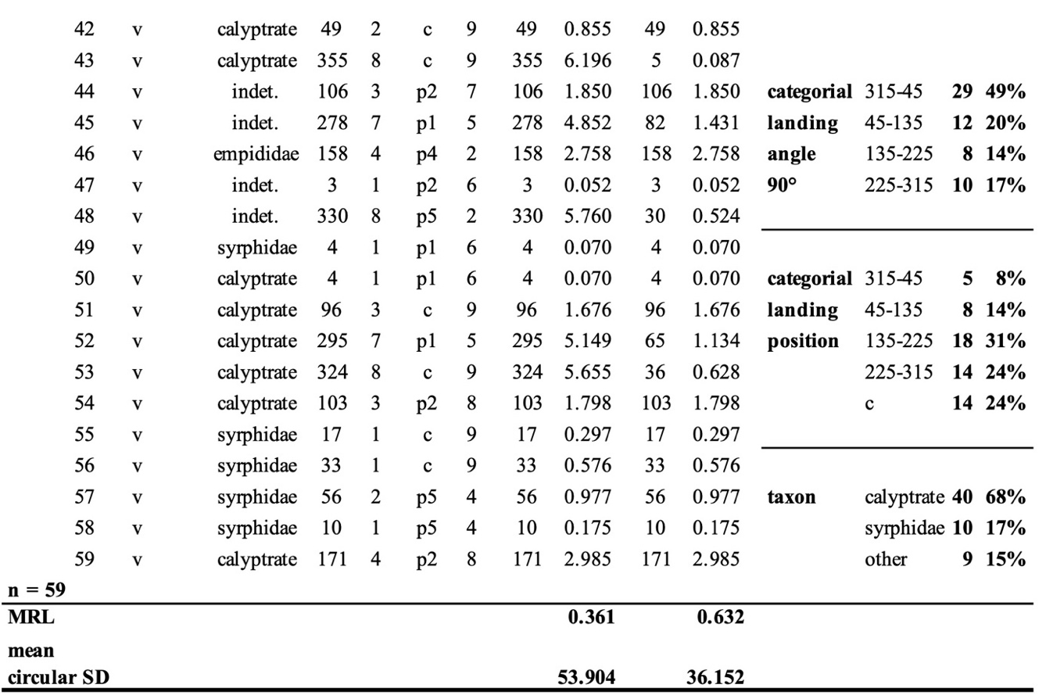

Data of S. stellaris vertical x monosymmetrical:
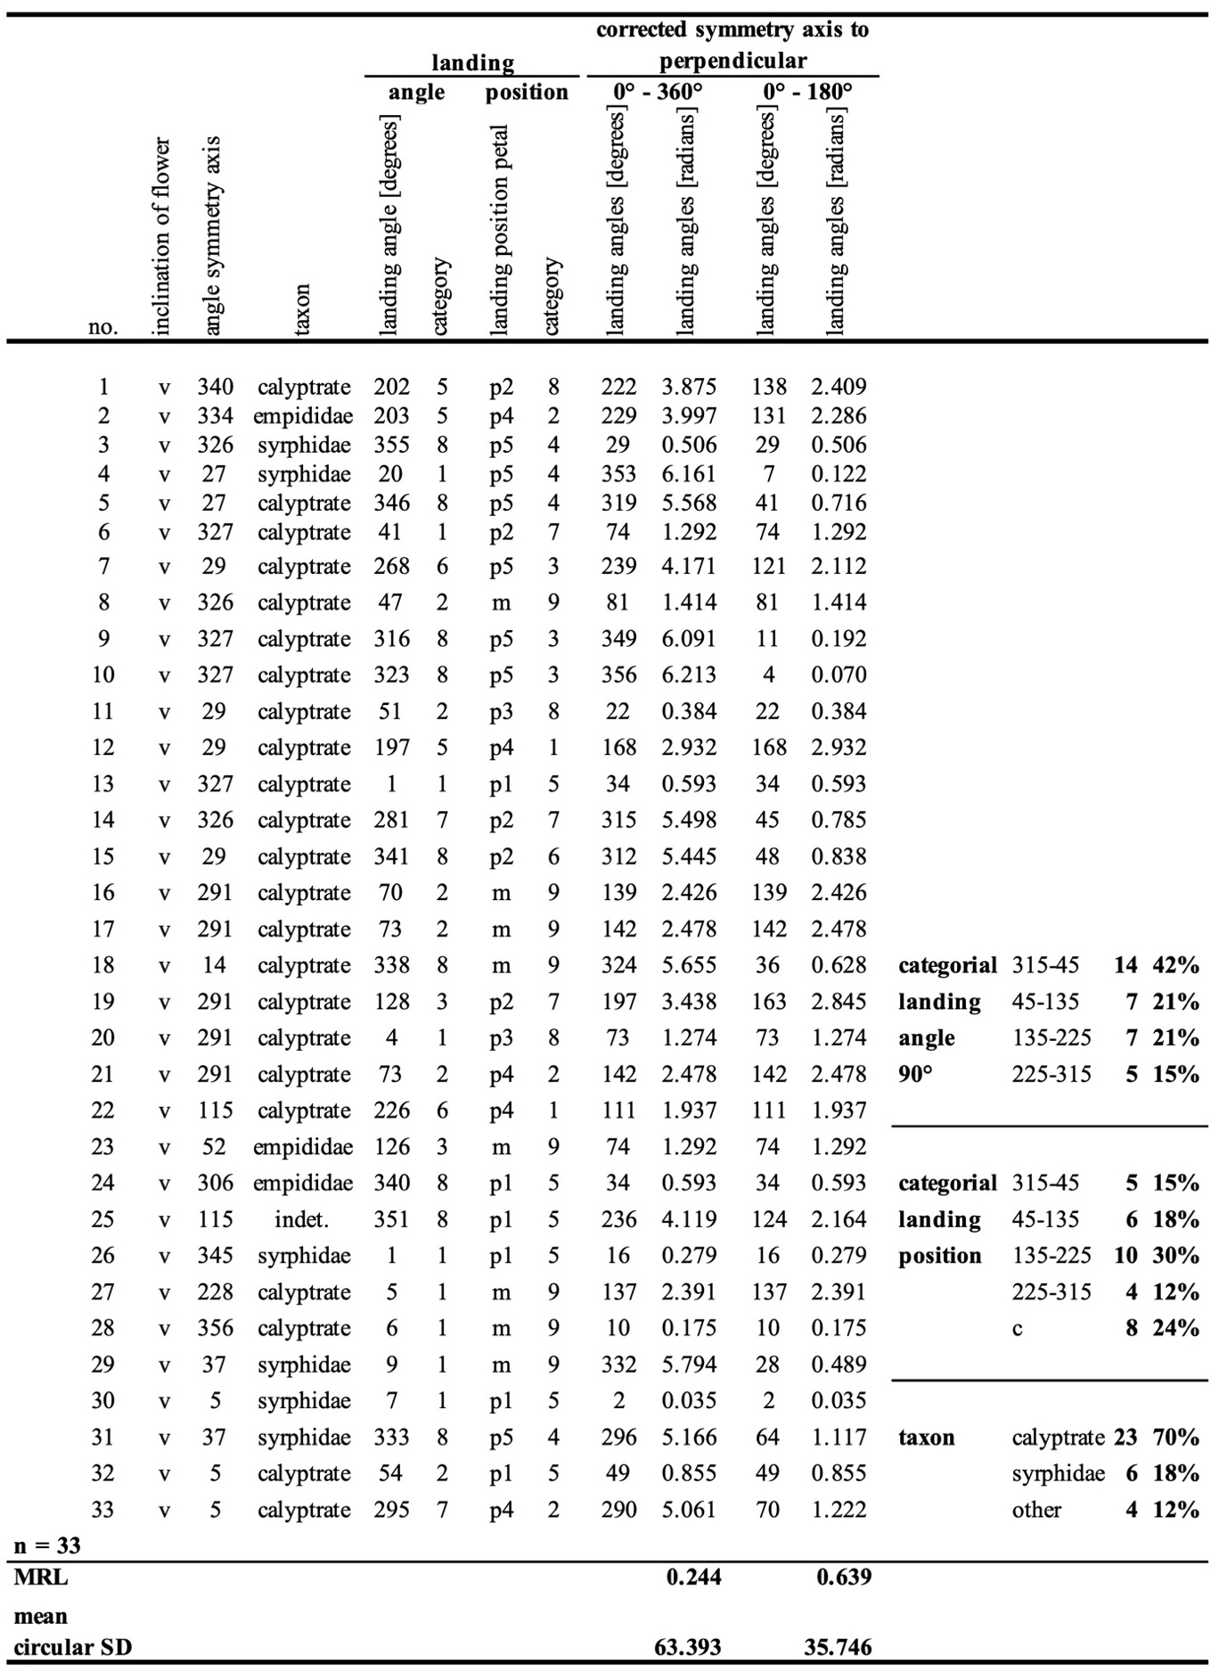

Data of the duration of flower visits:

Raw data of pollen surrogate deposition
