
Appendices to J Poll Ecol 39(25), van Kolfschoten & Vallejo-Marín
DOI: 10.26786/1920-7603(2025)894

Appendix I: Flight arena and flower setup
Figures showing the setup for the bee visiting experiment.
Figure A1: (a) shows the bumblebee colony on the left side that was connected with a transparent tube containing two consecutive doors leading to the 60 x 60 x 60 cm flight arena on the right side. The flight arena had LED lighting. In the flight arena are multiple twigs with bilberry flowers that were used to get the bees acquainted with handling the flowers. Photo (b) shows the inside of the flight cage with the experimental setup. The white coil on the left was used by the bees to help them climb back into the hole connecting the flight arena with the colony.
Appendix II: Experimental setup mechanical shaker
Photo of the experimental setup for the mechanical buzzing experiment.
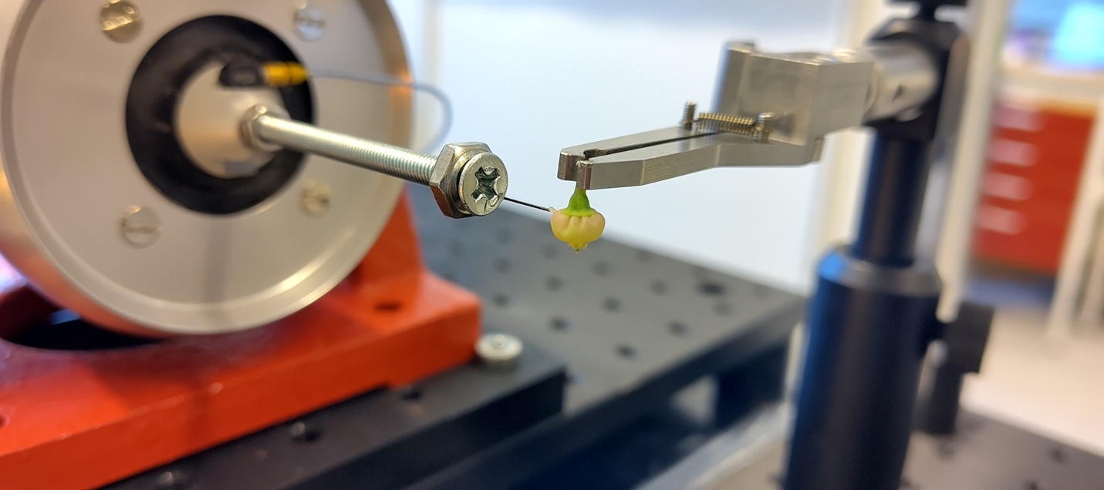
Figure A2: Experimental setup for the mechanical buzzing of the Vaccinium myrtillus flowers. The shaker is connected to an accelerometer to check if the correct buzzes were applied. Here you see the vertically mounted shaker with an up-ramped, sideways orientation, resulting in horizontally propagated vibrations, with the metal rod (size 4M) and with a 10 mm long enamelled insect pin (size 0) glued to its tip. On the right, you see the clamp that held the twig just above the base of the corolla. The pin was inserted into the upper half of the corolla to transfer the vibration. To prevent slippage during vibration, a small amount of honeybee wax was applied at the contact point.

Appendix III: Spur length comparison
Figure A3: Map with submaps with the sampling locations. Each number corresponds to a sampling location.
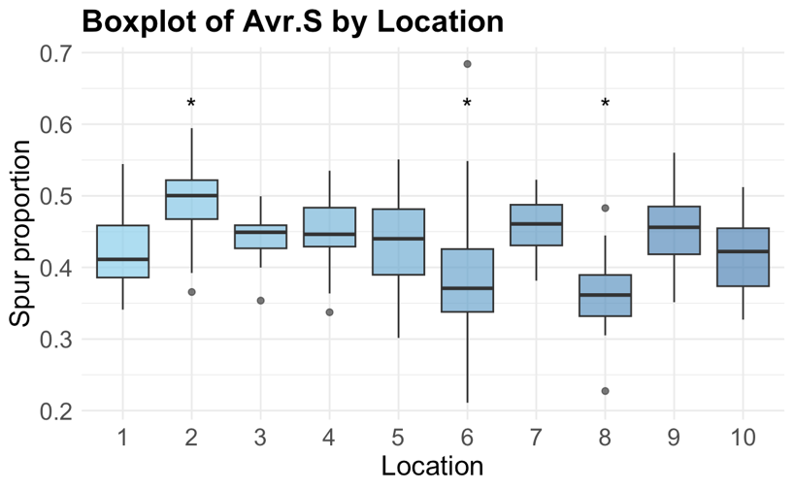
Figure A4: Visualization of the variability of spur proportion in ten different locations. Spur proportion is calculated as the spur length/anther length average.
Appendix IV: Comparing Pollen amount in flowers before bee visit in the two treatments
To make sure the removal of the spur did not remove pollen from the anther we compared unvisited flowers with each other. The results show there is no significant difference between the two groups (W=624.5, p=0.176). Continuing, we therefore, when calculating the proportion of pollen removed from the flowers in the bee visiting experiment, used all the unvisited flowers combined to estimate the number of pollen in the flower before a visit.
Figure A5: Boxplots showing the median and the spread of the estimated amount of pollen in the unvisited flowers that had either their spur removed (treatment No spur), or their spur remaining (Spur). There was no significant difference between the two groups.

Appendix V: Experimental results: mean and SD table

Bee experiment

Treatment | Pollen remaining Mean | Pollen remaining SD | Pollen removed Mean | Pollen removed SD | Proportion removed Mean | Proportion removed SD | Normalized  Mean | Normalized  SD | Transformed proportion removed Mean | Transformed proportion removed SD
Spur | 11875.42 | 8526.105 | 13941.73 | 8526.105 | 0.540 | 0.330 | 0.701 | 0.217 | 1.012 | 0.250
No spur | 10230.28 | 7846.612 | 15586.88 | 7846.612 | 0.604 | 0.304 | 0.743 | 0.200 | 1.058 | 0.247
Shaker experiment

Treatment | Pollen remaining Mean | Pollen remaining SD | Pollen removed Mean | Pollen removed SD | Proportion removed Mean | Proportion removed SD
Spur | 6343.614 | 5104.161 | 31081.68 | 9832.885 | 0.179 | 0.152
No spur | 10229.750 | 7756.101 | 25680.38 | 9433.038 | 0.282 | 0.204

Appendix VI: Visualisation of mixed effects model results

Figure A6: Proportion of pollen removed (arcsin-transformed) plotted against time on flower (log scale), with separate panels for buzzing and non-buzzing visits. Coloured lines and shaded areas represent treatment-specific model predictions and confidence intervals. During buzzing visits, flowers without a spur released more pollen than flowers with a spur. The prediction lines appear to cross when the visit duration exceeds a particular time span. However, these extrapolations are based on a few data points. In non-buzzing visits, pollen removal increased with time in flowers without a spur, whereas it remained stable in flowers with a spur. Note that the number of non-buzzing visits was relatively low (N = 19), so these results should be interpreted with caution.

